SHETRAN Standard Version – V4.5.3

User Guide and Data Input Manual

EXECUTIVE SUMMARY

This report contains detailed information on the setting up and use of the hydrological flow, sediment transport and contaminant migration (including nitrate) catchment modelling system SHETRAN Version 4.5.3

There are three main sections to the report. The first section describes the basics of setting-up and running a SHETRAN simulation. The next section consists of a detailed layout of the input data formats required by SHETRAN. This includes details for the flow, sediment, contaminant (including nitrate) components, including initialisation parameters, time-varying meteorological data and boundary data used during a simulation run. The inter-dependence between input parameters is clearly described. The final section describes the SHETRAN output and the method to view the results.

CONTENTS
1 INTRODUCTION TO RUNNING SHETRAN 1
1.1 SHETRAN Basics 1
1.2 Command line options 2
1.3 SHETRAN modules 3
1.4 SHETRAN Array Sizes 4
1.5 SHETRAN Rundata file 5
1.6 Setting Up Catchment Data 8
1.6.1 General layout of data input files 8
1.6.2 Catchment geometry 8
1.6.3 Output 10
1.6.4 Sediment and contaminant components 10
1.6.5 Time-varying boundary data files 10
1.6.6 Error handling 11
2 DATA INPUT FILE FORMATS 13
2.1 Introduction 13
2.2 Frame Module 15
2.3 Evapotranspiration/Interception Module 24
2.4 Overland/Channel Module 31
2.5 Variably Saturated Subsurface Module 38
2.5.1 Variably saturated subsurface data (VSD) file 38
2.5.2 Variably saturated subsurface initial conditions (VSI) file 47
2.6 Snowmelt Module 48
2.7 Bank Element Module 50
2.8 Sediment Transport Component 53
2.9 Contaminant Migration Components 59
2.10 Meteorology 64
2.10.1 Full meteorological data 64
2.10.2 Precipitation data 65
2.10.3 Potential Evaporation data 65
2.11 Time-Varying Boundary Conditions 67
2.12 Nitrate Component 69
2.12.1 Nitrogen and Carbon Data 69
2.12.2 External Carbon Inputs 75
2.12.3 External Nitrogen Inputs 76
2.12.4 Nitrogen Plant Uptake Parameters 77
2.13 Specification of Output Data 78
3 SHETRAN Results 84
3.1 Introduction 84
3.2 Catchment_Map and Catchment_Spreadsheet 84
3.3 Constants 85
3.4 Variables 89
Appendix A: Data File Formats for the Sediment and Contaminant Transport Components 94
Appendix B: Mobile Sediment Concentration in SHETRAN 96

TABLES

Table 1.1 Array sizes 5
Table 1.2 File unit numbers 6
Table 2.1 Overland/channel flow codes 22
Table 2.2 Time-varying boundary data files 66
Table 2.3 Special characters that can be used in visualisation_plan.txt 69
Table 2.4 Special lines that can be used in visualisation_plan.txt 69
Table 2.5 Properties for items in visualisation_plan.txt 71
Table 3.1 Constants recorded in shegraph.h5 file 76
Table 3.2 Data Types (dimensions) that can be recorded for grid datasets 79
Figures

Figure 1.1 File select window 2
Figure 2.1 Specification of grid size 16
Figure 2.2 Example visualisation plan 68
Figure 2.3 Constants and variables recognised for SHETRAN output 72
Figure 3.1 Shegrpah.h5 file showing the SV4_numbering in Catchment_Map 75
Figure 3.2 Shegrpah.h5 file showing SHETRAN element numbers 77
Figure 3.3 General properties for dataset number 77
Figure 3.4 Attributes for dataset number 78
Figure 3.5 Dataset for time and attributes for value, both for item 2 psi 80
Figure 3.6 A 1-D plot for dataset 2 psi in a Lineplot window 81
Figure 3.7 A 2-D plot for dataset theta in an ImageView window 82

1 INTRODUCTION TO RUNNING SHETRAN

SHETRAN Basics

SHETRAN should run on any Windows or Linux machine.

There is also a SHETRAN-prepare.exe that uses an XML (Library File) together with map files and time series data and sets up all the SHETRAN input files so that SHETRAN can be run. SHETRAN-prepare.exe and SHETRAN.exe are usually run sequentially using the start.exe or a Python script. This is the preferred method of setting up and running a SHETRAN simulation.

The SHETRAN-prepare.exe is not described here. There are some missing capabilities using the SHETRAN-prepare.exe, if these are needed the following User Guide is useful.

To run SHETRAN do the following:

- Download and unzip the model
- Go to the Shetran-Model folder
- Run a simulation. To run Shetran double-click Shetran.exe in the Shetran-Model folder. This opens a window (Figure 1.1). Use this to find the catchment's rundata directory, then double-click on the catchment's rundata file. [Note, if Shetran immediately stops and the window disappears then run from a command prompt window, the error message will then remain in the window]
- Look for a file named output_CATCHMENT-NAME_shegrpah.h5.
- Examine the output using any HDF5 application. If, for example, HDFView is the default HDF5 application (it will be, if it is the only HDF5 application you have installed), double-clicking on _CATCHMENT-NAME_shegrpah.h5 will automatically open HDFView and load shegraph.h5. HDFView is freely available software that can be downloaded from https://www.hdfgroup.org/download-hdfview/ and Panoply from https://www.giss.nasa.gov/tools/panoply/download/

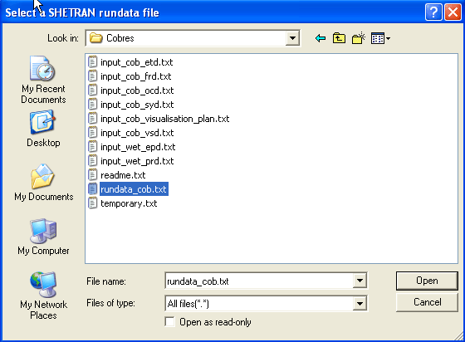
Figure 1.1 File select window

Command line options

The standard method of running SHETRAN is to double click on the shetran.exe in the progam directory. However there are other command line options that can be seen below:

Syntax:

executable [option][ name]

Where
executable is Shetran executable e.g. Shetran.exe
option is -c or -f (standing for 'catchment' and 'file')
name is a filename or catchment name

For option -c, the file 'catchments.txt' is searched for the catchment name.

Examples

Say the current directory contains the executable Shetran and a file called catchments.txt which contains only the following 6 lines of text:

default
c:\valsa\rundata\rundata.val
slapton
c:\slapton\rundata\rundata.sla
valsa
c:\valsa\rundata\rundata.val

Then the outcome is as follows:

Command Line Entry | Outcome
Shetran.exe | brings up a popup window, which asks for the rundata filename
Shetran.exe -c | runs the default (i.e. valsa)
Shetran.exe -c slapton | runs slapton
Shetran.exe -c valsa | runs valsa
Shetran.exe c:\slapton\rundata\rundata.sla | runs slapton
Shetran -f C:\ouse\rundata\rundata.ouse | runs ouse (Note: filename for -f option does not need to be listed in catchments.txt file)

SHETRAN modules

SHETRAN consists of 10 main modules

FR Frame module
ET Evapotranspiration module
OC Overland/channel module
VS Variably saturated subsurface module
BK Bank module (optional)
SM Snowmelt module (optional)
SY Sediment erosion and transport module (optional)
CM Contaminant transport module (optional)
MN Nitrate module (optional – requires CM module to be used)
ZQ Reservoir module (optional)

1.4 SHETRAN Array Sizes

SHETRAN is written mainly in FORTRAN 90. Some array sizes are specified before running SHETRAN, the dimensions of the main arrays must be checked to ensure that they are sufficiently large to accommodate the required catchment configuration (the program halted if the array sizes are too small). Below is a list of the dimensions sizes in the attached executable. These are now set to be very large and the main issue will be long run times rather than these array sizes.

Parameter | Meaning | Dimension
NXEE | Number of basic grid elements in the x direction | 1000
NYEE | Number of basic grid elements in the y direction | 1000
NELEE | Number of elements | 250000
NLFEE | Number of channel links | 20000
LLEE | Number of cells in the vertical | 50
NVEE | Maximum of the number of vegetation types, meteorological stations, and rainfall stations | 250000
NSEE | Number of soil types | 1000
NVSEE | Size of tables used in VS module | 20
NVBP | Number of time varying vegetation breakpoints | 140
NUZTAB | Size of tables used in ET module | 20
NLYREE | Maximum number of soil layers at any element | 20
NXOCEE | Maximum number of elements (grids, banks and links) in any row, including E-W links and banks on the southern edge of the row. Used for OC component matrix coefficients | 4000
NOCTAB | Size of tables in OC component (Maximum of number roughness categories, number of channel cross-section categories) | 20
NSEDEE | Number of sediment size fractions | 7
NCONEE | Number of contaminants | 3
Table 1.1 Array sizes

1.5 SHETRAN Rundata file

SHETRAN uses a number of different input and output files for setting up and controlling a simulation, and for storing output. The pathnames of the files used are set up in a rundata file, with the format:
Main title
Subtitle
File pathname
Subtitle
File pathname
...

If any file is omitted, the subtitle must still be included, with a blank line replacing the filename. Example of rundata files can be seen in the SHETRAN example datasets document. The order of the files and the file unit number correspond to those in Table 1.2 below.
File Unit  Number | Mnemonic  Variable | Description | Type
10  11  12  13  14  15  16  17  18  19  20  21  22  23  24  25  26  27  28  29  30  31  32  33  34  35  36  37  38  39  40  41  42  43  44  45  46  47  48  49  50  51  52  53  54  55  56  57  58  59  60 | FRD  VSD  OCD  ETD  PPD  SMD  BKD  SYD  CMD  MED  PRD  EPD  TIM  PRI  SPR  CPR  BUG  RES  HOT  VSI  VED  WLD  LFB  LHB  LGB  BFB  BHB  OFB  OHB  CMT  CMB  DIS  VSE  MAS  DIS  -  -  -  -  -  -  ZQD  PSLEXTRA  MND  MNFC  MNFN  MNPL  MNPR  MNOUT1  MNOUT2  MNOUTPL | Frame data  Variable saturated subsurface data  Overland/channel data  Evapotranspiration data  *  Snowmelt data  Bank element data  Sediment yield data  Contaminant data  Full meteorological data  Precipitation  Potential evaporation  Time-counter file  Formatted flow output  Formatted sediment yield output  Formatted contaminant output  Debug output (for code develop. only)  *  Hotstart file  VSS initial conditions  *  Well abstraction  Lateral subsurface flow boundary  Lateral subsurface head boundary  Lateral subsurface head gradient b’ry  Aquifer base flow boundary  Aquifer head boundary  Overland/channel flow boundary  Overland/channel head boundary  Contaminant migration boundary 1  Contaminant migration boundary 2  Regular discharge at outlet  Data for hotstart  Mass balance data  Discharge at outlet every timestep  Max temperature  Min temperature  Extra output discharge points  Visualisation_plan data  Check visualisation plan  Shegraph HDF output data  Weir Data  Water Table points  Nitrogen and Carbon data  External carbon input  External nitrogen input  Nitrate plant uptake input  Nitrate output  Nitrate extra output (carbon)  nitrate extra output (nitrogen)  Nitrate plant output | input  input  input  input  *  input (optional)  input (optional)  input (optional)  input (optional)  input (time-varying)  input (time-varying)  input (time-varying)  ASCII output  ASCII output  ASCII output  ASCII output  ASCII output  *  unformatted input / output  input initial conditions  *  input (optional time-varying)  input (optional time-varying)  input (optional time-varying)  input (optional time-varying)  input (optional time-varying)  input (optional time-varying)  input (optional time-varying)  input (optional time-varying)  input (optional time-varying)  input (optional time-varying)  ASCII output  ASCII output  ASCII output  ASCII output  input (optional time-varying)  input (optional time-varying)  input  input  ASCII output  HDF Output  input (optional)  input (optional)  input (optional)  input (optional time-varying)  input (optional time-varying)  input (optional time-varying)  ASCII output  ASCII output  ASCII output  ASCII output
* Not currently used
Table 1.2 File unit numbers

1.6 Setting Up Catchment Data

1.6.1 General layout of data input files

The catchment geometry and basic simulation control parameters are set up in the frame module (FR) data set. Logical flags (line FR25) are used to control execution of the optional bank (BK), snowmelt (SM), sediment (SY) and contaminant (CM) modules. Parameter data are read in from the appropriate data file for each component or module selected. The frame and the basic flow components are all mutually inter-dependent and are automatically used in every simulation (evapotranspiration (ET), overland/channel (OC), variably saturated subsurface (VS)). The visulisation_plan.txt file is used in every simulation and specifies the items to be recorded, when they are to be recorded, and for which locations in the catchment.

Meteorological data are read in throughout the simulation. Two methods of reading in the meteorological data are available, controlled by a logical flag in the ET data file (line ET2): full sets of meteorological data at regular intervals (MED file); or precipitation (PRD file) and potential evapotranspiration (EPD file), also read in at regular intervals.

Time-varying boundary conditions can be set up for the VS and OC components. The flags controlling these are in the parameter files for each of these components. All the boundary condition data files (time-varying heads or flows) are set up in a standard format.

1.6.2 Catchment geometry

Three types of elements are used to describe the finite difference representation of a catchment; basic elements (often called grid elements or grid squares, although they may be non-square rectangles - note however that graphically only squares can be depicted as the basic element), bank elements, and channel links. At the start of the initialisation phase of a simulation, each element is assigned a unique element number, which is used both for data input and internally throughout the program.

Each element has four faces, numbered 1 (east), 2 (north), 3 (west), 4 (south). These are used to define OC boundary data (e.g. weir locations). Output data in the shegraph.h5 file (section 3) is displayed using the standard numbering system for faces, numbered 1 (north), 2 (east), 3 (south), 4 (west).

The basic catchment topography (catchment boundary and drainage network) and geometry (grid sizes, basic ground surface level) are set up in the FR data file. The sizes of the vertical cells for the VS and CM components are set up in the VS data file. The cell sizes are referred to ground level at each element. Soil horizons and impermeable bed elevations are also defined in the VS file. Soil horizon and impermeable bed elevations are automatically adjusted to lie on the nearest cell boundary at each grid square.

The detailed channel geometry (cross-section, and channel bed elevation) is set up in the OC data file. A unique cross-section can be assigned individually to each channel link. If a group of channel links have identical cross-sections, they can be assigned the same cross-section category code, and the width/elevation pairs describing the cross-section need only be input once for that category. The bank-full elevation (used to control overbank flooding) is established as the elevation above the channel bed of the last value in the cross-section table. Two types of channel cross-section are used internally within SHETRAN: channel flow is calculated using the cross-sections input by the user; subsurface flow exchanges use an effective rectangular channel with the same cross-sectional area as the input channel.

Bank elements are narrow strips of land at either side of the channel, automatically set up for every link whenever the bank component is included. It is assumed that channel link and bank element widths are small compared with the basic grid sizes. The bank element width is hard-coded within the program as 10 metres. All other data for bank elements are input in the BK data file. The elevation of the impermeable bed at each bank element must be at least 0.5 metres below the channel bed at the adjacent link.

1.6.3 Output

The standard method of obtaining results from SHETRAN is via HDF files, with the type of output specified in the visulisation_plan.txt file. When SV4 is run, an echo file is written automatically in the catchment's output sub-directory as a file named check_visualisation_plan.txt. ASCII print output is held in a separate file for flow (PRI), sediment (SPR), contaminants (CPR) and nitrate (MNPR). These contain initialisation phase information, diagnostic warning and error messages, some further data output and summary statistics. During normal simulations these need not be used for data output.

1.6.4 Sediment and contaminant components

Either the sediment component or the contaminant components (called the transport components), or both, may be selected in addition to the flow components, by setting the appropriate flags in the frame data file (line FR25). Either of these may be selected in the absence of the other or both may be selected. If the contaminant migration component is selected, the bank element component must be included.

The transport components can be started later than the flow components, to allow any inconsistencies in the flow initial conditions to decay before the transport components are introduced. The usual procedure is to run only the flow components until a satisfactory flow simulation is established. The simulation is then re-run with the transport components included.

1.6.5 Time-varying boundary data files

Prescribed time-varying boundary conditions can be set up for the OC and the VS components. Boundary conditions for the OC component are specified channel discharge or stage, and overland water level or flow. Boundary conditions for the VS component are specified lateral subsurface head and flow, aquifer bed head and flow, and well extraction rate.

All time-varying boundary data files are in a standard format with values given at breakpoint times. Head or stage boundary data are interpolated at each timestep between the given values. Flux boundary data are given as constant values up to the breakpoint time, and values for each timestep are calculated as the equivalent averaged value over the computational timestep.

In all cases, the boundary elements are assigned boundary category codes, and the time-varying data are read in for each category. If different time-varying conditions are required for each boundary element, a unique category code must be assigned to each element.

Boundary conditions may not be specified for bank elements (other than regional aquifer flows).

1.6.6 Error handling

SHETRAN is a highly flexible modelling system, capable of simulating hydrological flow and transport for a wide variety of catchment sizes and configurations. In order to retain this degree of flexibility, as few restrictions as possible have been imposed on the relationships between parameter values for each of the components, and on the catchment geometry, including the sizes of the elements and vertical cells.

It is the user's responsibility to ensure that data sets are self-consistent and physically plausible. The use of parameter values outside physically realistic bounds, and the use of inappropriate modelling parameters such as tolerance criteria or grid spacings, is likely to result in physically unrealistic, inaccurate, or unstable simulations. Any user of SHETRAN should therefore have sufficient hydrological and modelling experience to use the complexities of the system correctly.

A minimum amount of necessary checking of the input data files is made, where obvious inconsistencies may occur. In addition, the simulation is monitored, and messages written to the print output files (PRI, SPR, CPR, MNPR). Each message is given a unique number, which is printed along with the element and cell numbers (where applicable), the simulation time, and a short error message on the same line. The first digit of the error number indicates in which component the error originated:

- General library routines;
- Water flow components;
- Sediment component;
- Contaminant and Nitrate components.

A longer message description may follow the summary message line.

Three types of message are written, of increasing severity:

WARNINGS: warning messages are written for example, where input data have been adjusted, or where mass balance errors exceed certain values;

ERRORS: error messages may be written due to inconsistencies in input data sets, or where unphysical values have occurred during a simulation, but where the situation is recoverable;

FATAL ERRORS: a fatal error is written if the simulation terminates prematurely, as a result of either errors in input data sets, or non-recoverable unphysical situations during the simulation.

A complete listing and summary of all errors may be found in a subdirectory ‘helpmessages’ within the main program directory. Note: this needs updating

2 DATA INPUT FILE FORMATS

2.1 Introduction

Some of the SHETRAN data files are set out in a fixed format, described in the following sections for each component. Some of the data are input in a 7 character format. Where free format (*) is used, the input variable type is signified by the first letter of the variable name, following FORTRAN 77 defaults (double precision, A-H, O-Z; integer, I_N). Each of the groups of data items is preceded by a title line, which can be used for documenting the following lines of data. In addition, a general title for the simulation is held in the first line of the frame data file. A slightly different format is used for the sediment and contaminant input data files: this is discussed in Appendix A.

Each data line in each file is described with reference to a short identifier code (e.g. FR5). To retain consistency between versions of SHETRAN where input data are changed, the codes are not renumbered, so that lines may have been inserted (e.g. FR35a-FR35d), or removed (e.g FR40-FR42).

The variable names described in the input data formats are mostly the FORTRAN variable names used in the program. However, where processing of the input data occurs in the initialisation phase of a simulation, the internal variable names may differ from those described in this report.

Distributed data are held in grid arrays in a standard format for grid elements. Real arrays consist of a title line, and the grid row numbers in descending order, each followed by the row of data, extending over several lines if necessary. See the ground surface elevation array, ZGRUND (lines FR37-FR39), for an example of a real variable array. Integer arrays are normally input in a simpler format, with the row number and the row of data on the same line. See the vegetation distribution array, NMC (lines FR43-FR44). This input format is only used if the number of possible categories in the array (e.g the number of vegetation types) is less than 10 (so that the one-character format is sufficient). If the number of categories is greater than or equal to 10, a full grid format is automatically used, in the format:

(I7) IY
IY row number (in descending order)
(20I4) (IDUM (J,IY), J=1,NX)
IDUM input array
NX number of grid squares in x-direction

Distributed data for the bank elements are input separately in the bank component data file. Although the bank module is part of the frame component its use is optional, so its input data file format is presented after those for the water flow component in this manual.

In many cases, the input of distributed data can be simplified by defining categories of types, each sharing a common data value. The indication of a category value for an element, rather than an individual value, is generally achieved by using a negative category code rather than a positive element number. See for example, the use of default channel cross-sections (OC30-OC34), and the use of category codes in the time-varying boundary conditions in the OC and VS components.

Many of the lines of input data must be repeated, either as single lines (eg meteorological grid codes FR44), or as groups of data (e.g. vegetation parameters, ET7-ET18). These are indicated in the format descriptions by a repeat count, including reference to the line where the repeat count number is input.

Depending upon the options chosen and the complexity of the input data set, some lines of the data files may be omitted. These lines need only be included if the condition under the 'data only required if' column is true. This column includes a reference to the line where the condition variable is set. Note that the condition is entered against the title line of a group of data items, but refers to the whole group of items. For example, the meteorological grid code array (lines FR43-FR44) need only be input if no default code has been entered (i.e. IDMC is zero in line FR33).

2.2 Frame Module

Code | Format | Description | Repeat Count | Data Only Required If: | Notes

FR1: | (20A4)  TITLE | TITLE  General title for the simulation.

FR2: | (20A4)  TITLE | TITLE  Description of data on the next line(s).
FR3: | (*)  NX  NY | NX, NY  Number of grid squares in the x-direction.  Number of grid squares in the y-direction. |  |  | NX and NY should be set equal to the maximum number of "active" grid squares plus 2 in each of the two directions.

FR4: |  | TITLE
FR5: | (*)  ISYEAR  ISMTH  ISDAY  ISHOUR  ISMIN | ISYEAR, ISMTH, ISDAY, ISHOUR, ISMIN  Start year of simulation.  Start month of simulation.  Start day of simulation.  Start hour of simulation.  Start minute of simulation.

FR6: |  | TITLE
FR7: | (*)  IEYEAR  IEMTH  IEDAY  IEHOUR  IEMIN | IEYEAR, IEMTH, IEDAY, IEHOUR, IEMIN  End year of simulation.  End month of simulation.  End day of simulation.  End hour of simulation.  End minute of simulation.

FR7a: |  | TITLE
FR7b: | (*)  JSYEAR  JSMTH  JSDAY  JSHOUR  JSMIN | JSYEAR, JSMTH, JSDAY, JSHOUR, JSMIN  Start year for sediment simulation.  Start month for sediment simulation.  Start day for sediment simulation.  Start hour for sediment simulation.  Start minute for sediment simulation. |  |  | If the sediment or contaminant components are not included (see line FR25, lines FR7a-FR7d are ignored.

FR7c: |  | TITLE
FR7d: | (*)  JCYEAR  JCMTH  JCDAY  JCHOUR  JCMIN | JCYEAR, JCMTH, JCDAY, JCHOUR, JCMIN  Start year for contaminant simulation.  Start month for contaminant simulation.  Start day for contaminant simulation.  Start hour for contaminant simulation.  Start minute for contaminant simulation.

FR8: | (20A4) | TITLE
FR9: | (10F7.0)  DXIN | (DXIN(J), J=1, NX-1)  Distances (metres) between nodes in x-direction. |  |  | The grid boundaries are at the midpoints between adjacent nodes (see Fig. 2.1)

FR10: | (20A4) | TITLE
FR11: | (10F7.0)  DYIN | (DYIN(K), K=1, NY-1)  Distance (metres) between nodes in y-direction. See Fig. 2.1. Data is input from the bottom to the top |  |  | The program calculates the actual grid sizes DXQQ and DYQQ from DXIN and DYIN respectively.

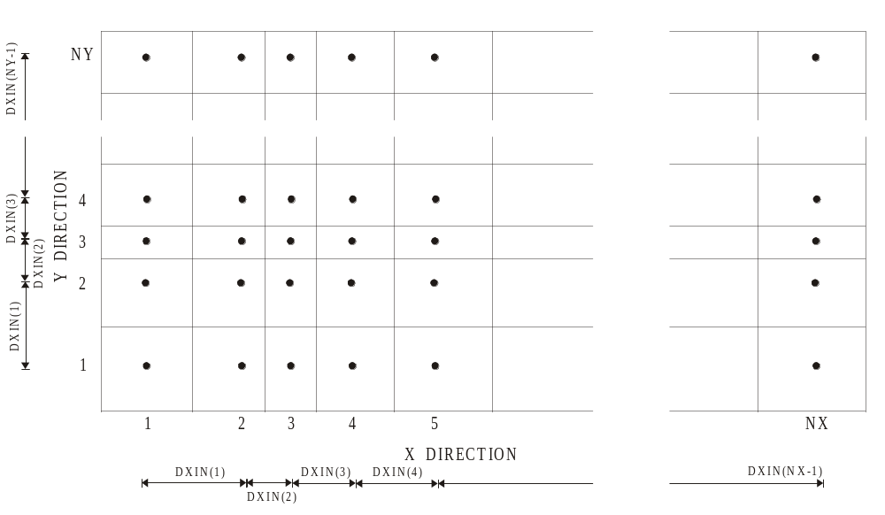

Figure 2.1 Specification of grid size

FR12: | (20A4) | TITLE
FR13: | (F7.0,I7,4L7,  F7.0)  DTAO  IAOUT  BINFRP  BFRTS1  BFRTS2  BSTORE  PSTART | DTAO, IAOUT, BINFRP, BFRTS1, BFRTS2, BSTORE, PSTART  Timestep (hours) between print output of results. This applies only to the end results of the computations in each component as described below.  = 1 gives a "molecular" print at DTAO intervals where all results for each point are printed together. Results at all model points are obtained.  = 2 gives a print of selected results at DTAO intervals where each result for the whole model area is printed as a separate array. This option is usually used.  = .TRUE. for a print of all the data read and set-up by the frame during its initialisation phase.  = .TRUE. for a screen output of the calculation sequence during the simulation.  = .TRUE. for a print of all the data passed from the frame to the components and back to the frame at each timestep.  = .TRUE. for the old method of outputting result data  Start time (hours) for printing of results on PRI file. |  |  | .

FR20: | (20A4) | TITLE
FR21: | (4F7.0,0L7)  PMAX  PALFA  QMAX  TMAX  BSOFT | PMAX, PALFA, QMAX, TMAX  Maximum rainfall volume (mm) allowed in one timestep (hours).  Rate of increase of timestep after reduction. The timestep is increased until the basic timestep TMAX is reached.  Maximum river discharge (m³/s) allowed in one timestep. Basic timestep (hours).  =TRUE to activate ‘soft start’ facility |  |  | Parameters PMAX and PALFA are hardcoded;  PMAX = 1.0  PALFA = 0.15  Values entered into the frd file are ignored. The maximum allowable value for TMAX is 2 hours.  The ‘soft start’ facility shortens the timestep at the start of the simulations, the enable the system to cope with imbalances in initial conditions

FR22: | (20A4) | TITLE
FR23: | (10L7)  BPPNET  BPEPOT  BPQOC  BPDEP  BPQF  BPQH  BPQSZ  BPHSZ  BPBAL  BPSD | BPPNET, BPEPOT, BPQOC, BPDEP, BPQF, BPQH, BPQSZ, BPHSZ, BPBAL, BPSD  Indicators of which results are required to be printed at the DTAO intervals.  = .TRUE. for net rainfall.  = .TRUE. for potential evapotranspiration.  = .TRUE. for overland flows.  = .TRUE. for depths of overland flows.  = .TRUE. for river levels and flows.  = .TRUE. for infiltration.  = .TRUE. for saturated zone flow.  = .TRUE. for phreatic surface level.  = .TRUE. for mass balance state.  = .TRUE. for printing snowpack depth, temperature and snowfall.

FR24: | (20A4) | TITLE
FR25: | (4L7)  BEXSM  BEXBK  BEXSY  BEXCM | BEXSM, BEXBK, BEXSY, BEXCM  Component execution control parameters  = .TRUE. if the SM component is to be included in the simulation.  For the BK component.  For the SY component.  For the CM component. |  |  | The frame component (FR) and the basic flow modules (ET, OC, VS) are automatically run for every simulation. The bank (BK) and snowmelt (SM) flow components may be omitted if not required. If the CM component is included, however, the BK component must also be included.

FR26: | (20A4) | TITLE
FR27: | (2L7, 2F7.2)  BHOTRD  BHOTPR  BHOTTI  BHOTST | BHOTRD, BHOTPR, BHOTTI, BHOTST  = .TRUE. for reading of initial conditions from hotstart file.  = .TRUE. for printing of relevant variables on hotstart file.  Time for hotstart of simulation.  Timestep for storing data on hotstart file.

FR28: |  | TITLE
FR29: | (5I7)  NM  NRAIN  NV  NDUM1  NDUM2 | NM, NRAIN, NV, NDUM1, NDUM2  Number of meteorological data stations.  Number of rainfall data stations.  Number of vegetation types in the model area.  Value read in but not used  Value read in but not used. |  |  | NRAIN must be equal to or greater than NM. In the case that NRAIN = NM, one would normally expect the meteorological and rain codes also to be the same, that is NRAINC = NMC (lines FR43-FR47).

FR30: | (20A4) | TITLE
FR31: | (L7, 2F7.0, L7)  LDUM1  DUM1  DUM2  LDUM2 | LDUM1,DUM1,DUM2,LDUM2  Value read in but not used  Value read in but not used  Value read in but not used  Value read in but not used

FR32: | (20A4) | TITLE
FR33: | (5I7)  IDMC  IDRA  IDVE  IDUM | IDMC, IDRA, IDVE, IDLYR  Default values for meteorological, rain, vegetation and soil codes.  Default meteorological grid code.  Default rainfall grid code.  Default vegetation type grid code.  Value read in but the value 1 is used |  |  | If the value of any of the parameters is zero, a corresponding array of codes for all grid elements is entered below (note that bank data are entered separately).  If a value is non-zero, this is used as the default value for all grid elements.

FR34: | (20A4) | TITLE
FR35: | (I7, 1X, 72I1)  IY  NGRID | IY, (NGRID(J,IY), J=1, NX)  (Integer array, see introduction)  Model grid line IY (used for checking the data).  Computation grid code. It can be given the following values:  1: Normal computational element inside the model area.  0: Element outside the model area where no computation or data are required. | NY  (FR3) |  | In the current version, the size of the grid is limited to 72 elements in the x direction.

FR35a: | (20A4) | TITLE
FR35b: | (I7, 1X, 72A1)  LCODEX | (IY, LCODEX(J,IY), J=1, NX+1)  The flow code, which defines the boundaries between grid overland elements in the West-East direction, or river links running North-South, for model line IY (see Table 2.1). | NY

FR35c: | (20A4) | TITLE
FR35d: | (I7, 1X, 72A1)  LCODEY | (IY, LCODEY(J,IY), J=1, NX)  The flow code, which defines the boundaries between grid overland elements in the North-South direction, or river links running West-East, for model boundaries below line IY (see Table 2.1). | NY+1

Code | Mnemonic | Description
1  2  3  4  5  6  7  8  9  10  11 | I  .  R  W  A  H  F  P | Impermeable boundary  Internal overland flow  Overland head boundary†  Overland flux boundary†  Overland polynomial function boundary†  River link  Weir link  River and weir in parallel  River head boundary  River flux boundary  River polynomial function boundary

† Note that overland boundary conditions are specified for individual elements in the OC data file, and are not entered in the OC definition grids.

Table 2.1 Overland/channel flow codes

FR37: | (20A4) | TITLE
FR38: | (I7) | IY | NY
FR39: | (10G7.0)  ZGRUND | (ZGRUND(J,IY), J=1, NX)  Ground surface elevation at all elements on the model grid line IY (metres above datum). | NY

FR43: | (20A4) | TITLE |  | IDMC=0
FR44: | (I7,1X,72I1)  NMC | IY, (NMC(J,IY), J=1, NX)  (Integer array, see introduction)  Meteorological grid codes at all elements on the model line IY. | NY | (FR33)

FR46: | (20A4) | TITLE |  | IDRA=0
FR47: | (I7,1X,72I1)  NRAINC | IY, (NRAIN(J,IY), J=1, NX)  (Integer array, see introduction)  Rainfall station grid codes at all elements on the model line IY. | NY | (FR33)

FR49: | (20A4) | TITLE |  | IDVE=0
FR50: | (I7,1X,72I1)  NVC | IY, (NVC,J,IY), J=1, NX)  (Integer array, see introduction)  Vegetation type code at all elements on the model line IY. | NY | (FR33)

FR52: | (20A4) | TITLE
FR53: | (*)  FROUTPUT | .Simulated discharge is averaged over this value. |  |  | Optional – Default is 24 hours

2.3 Evapotranspiration/Interception Module

Code | Format | Description | Repeat Count | Data Only Required If: | Notes
ET1: | (20A4)  TITLE | TITLE  Description of data on the next line(s).

ET2: | (4L7)  BMETP  BINETP  BMETAL | BMETP, BINETP, BMETAL  If .TRUE., the meteorological input data are printed once they have been read in.  If .TRUE., the ET input data are printed once they have been read in.  If .TRUE., the reading procedure for the PRD and EPD data files is used. |  |  | If BMETAL is .TRUE., only potential evapotranspiration is available, and MODE=3 (ET8) must be used.
 | BMETDATES | Optional. If .TRUE., the first column in PRD and EPD data files must have dates in ISO8601 format. The default is no dates are present

ET3: |  | TITLE
ET4: | (*)  DTMET  DTMET2  DTMET3 | DTMET,DTMET2,DTMET3  Timestep (hours) for updating of full meteorological data (MED) file  Timestep (hours) for updating of precipitation data (PRD) file  Timestep (hours) for updating of potential evaporation data (EPD) file

ET5: | (20A4) | TITLE
ET6: | (10I7)  MEASPE | (MEASPE(I), I=1, NM)  Control parameter.  = 1 potential evapotranspiration is measured and is read from meteorological file.  = 0 potential evapotranspiration is not measured. |  |  | If MEASPE=1 and no other meteorological data are available, MODE=3 (ET8) must be used. If MEASPE=1 and the full set of meteorological data are available, or if MEASPE=0, MODE=1 or 2 (ET8) can also be used.

START OF LOOP OVER VEGETATION TYPES (NV): lines ET7-ET18.

ET7: | (20A4) | TITLE | NV
ET8: | (L7,5F7.0,I7/I7,  4F7.0,I7,3F7.0)  I  BAR  RA  ZU  ZD  ZO  RC  MODE  NF  PLAI  CSTCAP  CK, CB  NRD  CLAI  VHT  RDL | BAR(I), RA(I), ZU(I), ZD(I), ZO(I), RC(I), MODE(I), NF(I), PLAI(I), CSTCAP(I), CK(I), CB(I), NRD(I), CLAI(I), VHT(I), RDL(I)  Running index for vegetation type.  Logical variable, which determines how the aerodynamic resistance RA is to be evaluated.  If .TRUE., a value of RA does not need to be specified, but values for ZU, ZD and ZO are required. If .FALSE., a constant value of RA is used and must be specified, but values of ZU, ZD and ZO are not required.  Aerodynamic resistance (s/m).  Height of the anemometer above the ground (m).  Zero plane displacement (m).  Roughness height of the vegetation canopy (m).  Canopy resistance (s/m).  The mode by which actual evapotranspiration is to be calculated.  = 1, a constant value of RC is used varying only with vegetation type.  = 2, RC is set to vary with soil moisture tension as well as with vegetation type.  = 3, actual evapotranspiration is derived from the dependency of the ratio of actual/potential evapotranspiration on soil moisture tension.  Number of rows in the above-mentioned table of parameters dependent on soil moisture tension. If MODE = 1, NF is a dummy variable.  The proportion of ground covered by vegetation at its maximum seasonal extent (between 0 and 1).  Canopy storage capacity (mm).  Drainage parameters K and b (mm/s and mm⁻¹ respectively).  Number of UZ node points which lie in the root zone.  The canopy leaf area index, defined as the ratio of total projected leaf area to area of ground covered by vegetation. It can exceed unity.  Vegetation height (m). At present this is required for the snowmelt calculations only.  Proportion of roots that take water from the channel (bank elements only). If greater than zero, the total of the root distribution function (RDF in line ET18) is reduced to (1-RDL). | (FR29)  NV | If MODE = 1, the value of RC is important. If MODE = 2 or 3, the necessary data are tabulated elsewhere, see below (ET15-ET16).

ET9: | (20A4) | TITLE | NV
ET10: | (4I7)  MODECS  MODEPL  MODECL  MODEVH | MODECS(I), MODEPL(I), MODECL(I), MODEVH(I)  = 1, time-varying CSTCAP.  = 0, otherwise.  = 1, time-varying PLAI.  = 1, time-varying CLAI.  = 1, time-varying VHT. | NV |  | If all the MODEs are zero no further data concerning a time-varying parameter are necessary. However, if any of the MODEs are 1, the following data are needed for the parameter in question. This is illustrated by reading time-varying CSTCAP below.

ET11: | (20A4) | TITLE | NV | MODECS=1
ET12: | (I7)  NUMCST | NUMCST(I)  Number of rows in the table giving the variation of the parameter with time. | NV | (ET10)  (similarly for MODEPL, MODECL, MODEVH)

ET13: | (20A4) | TITLE | NV
ET14: | (2G7.3)  RELCST  TIMCST  J | RELCST(I,J), TIMCST(I,J)  Ratio of value of CSTCAP at time TIMCST to the initial value of CSTCAP at time zero (specified on record ET).  Specified time (days).  Row index. | NV, NUMCST  (FR29, ET12) |  | The last value of TIMCST must exceed the length of the simulation period and the differences between successive values of TIMCST must exceed the difference between successive values of METIME.  Lines ET11-ET14 may be repeated for other time-varying parameters.

ET15: | (20A4) | TITLE | NV | MODE=2 or 3
ET16: | (3F7.2)  PS1  RCF  FET  N1 | (PS1(I,J), RCF(I,J), FET(I,J), J=1, N1)  Soil moisture tension (m).  Canopy resistance (s/m).  Actual/potential evapotranspiration.  NF(I) see line ET8. | NV | (ET8) | This method (as well as MODE 1) can be adapted to give actual evapotranspiration as a quantity independent of soil moisture. If only one row is entered in the table (NF=1) then the one value of RCF is used for canopy resistance if MODE=2 and the one value of FET is used for the ratio of actual to potential evapotranspiration if MODE=3. This holds as long as the current value of soil moisture tension is negative. If it is zero or positive, RC takes the default value of RCF and FE takes the value 1.0.

ET17: | (20A4) | TITLE | NV
ET18: | (2F7.4)  DEPTH  RDF  J | DEPTH, RDF(I,J)  Depth below ground surface.  The proportion of the roots at DEPTH. The sum of RDF over the root zone should be one.  Running index from 1 to NRD. | NV, NRD  (FR29, ET8) |  | ET18 is repeated NRD(I) times, see ET8.  The distances of DEPTH are for reference only. The RDF values correspond to the depth of each UZ node, so the values of DEPTH should correspond to the vertical distance steps DDZ(I,L) read in the UZ data file (line UZ21).

END OF LOOP OVER VEGETATION TYPES

2.4 Overland/Channel Module

Code | Format | Description | Repeat Count | Data Only Required If: | Notes
OC1: | (A80) | TITLE
OC1a: | (3I7,L7)  NT  NCATR  KONT  BIOWAT | NT, NCATR, KONT, BIOWAT  Number of different timesteps used in the simulation.  Number of different categories of roughness parameters in the grid squares.  > 0 the roughness parameter distribution across the model area is defined by the distribution of the categories read in STRX and STRY (OC14-19) and CATR (OC4).  = 0 the roughness parameter distribution across the model area is defined directly by the values read in STRX and STRY if CDRS = 0 (OC3a), or by the value of CDRS if it is greater than zero.  Print control parameter.  = 0 no print.  = 1 print of initialisation data and initial phase results.  = 2 print from simulation phase only.  = 3 extensive print from both phases.  If .TRUE., then initial overland flow levels are entered below (OC5-OC7). If .FALSE., then no initial overland flow exists. |  |  | KONT determines only output from the OC routines; the output of results from the FRAME are often sufficient during the simulation phase.

OC2: | (20A4) | TITLE
OC2a: | (10F7.0)  PT  TEMPS | (PT(I), TEMPS(I), I=1, NT)  Timestep (hours) for the OC-computations.  Corresponding end time (hours) for validity period of timestep PT. |  |  | The values of PT and TEMPS in line OC2a are presently not used, as the timestep specification is made in the FRAME dataset.

OC3: | (20A4) | TITLE
OC3a: | (5F7.0)  SMIN  CDRS  TDC  TFC  DET | SMIN, CDRS, TDC, TFC, DET  Minimum surface area of a river node (not used).  Default value of overland flow roughness parameter.  > 0 The value of CDRS will be used in all grids.  = 0 The roughness parameters will be defined by STRX and STRY, see below (OC14-OC19).  Time (hours) for start of print control output (for KONT>1).  Time (hours) for termination of print control output (for KONT>1).  Homogeneous detention storage parameter (metres) applied all over the grid (not currently used).
OC4: | (10F7.0)  CATR | (CATR(I), I=NCATR)  Roughness coefficient attached to category I (m^{1/3}s⁻¹). |  | CDRS=0 (OC3a) and NCATR ≠ 0 (OC1a) | The distribution of the categories is read later, see STRX and STRY below (OC14-OC19).

OC5: | (20A4) | TITLE |  | BIOWAT=.TRUE.
OC6: | (I4)  IY | IY  Model grid line IY (used for checking the data). | NY | (OC1a)
OC7: | (10G7.0)  HRF | (HRF(J,IY), J=1, NX)  Initial depth of overland water (m) at all elements in model line NY. | NY

OC14: | (20A4) | TITLE |  | CDRS=0 (OC3a)
OC15: | (I7) | IY | NY
OC16: | (10F7.0)  STRX | (STRX(J,IY), J=1, NX)  For NCATR = 0, table of roughness parameters for each grid square for model line IY.  For NCATR ≠ 0, table of category belonging to each grid square for model line IY. (NB these integers are input in I7 format). | NY

OC17: | (20A4) | TITLE
OC18: | (I7) | IY | NY | CDRS=0 (OC3a)
OC19: | (10F7.0)  STRY | (STRY(J,IY), J=1, NX)  Analogous to STRX in y-direction. | NY

OC20: | (20A4) | TITLE
OC21: | (3I7)  NOCHB  NOCFB  NOCPB | NOCHB, NOCFB, NOCPB  Number of head boundary categories.  Number of flux boundary categories.  Number of polynominal function boundary categories. |  |  | NOCHB, NOCFB, NOCPB apply to grid and channel elements (see FR35a-d and Table 2.1). If only channel boundary conditions are used, the grid arrays (OC22-OC27) must still be read in.

OC22: | (20A4) | TITLE
OC23: | (I7,1X,72I1)  IDUM | IY, (IDUM(J,IY), J=1, NX)  (Integer array, see introduction)  Array of head boundary categories for each grid element. | NY | NOCHB > 0  (OC21)

OC24: | (20A4) | TITLE
OC25: | (I7,1X,72I1)  IDUM | IY, (IDUM(J,IY), J=1, NX)  (Integer array, see introduction)  Array of flux boundary categories for each grid element. | NY | NOCFB > 0  (OC21)
OC26: | (20A4) | TITLE
OC27: | (I7,1X,72I1)  IDUM | IY, (IDUM(J,IY), J=1, NX)  (Integer array, see introduction)  Array of polynominal function boundary categories for each grid element. | NY | NOCPB > 0  (OC21)

OC28: |  | TITLE
OC29: | (I7,5F7.0)  ICAT  OCPBA  OCPBB  OCPBC  OCPBD  OCPBE | ICAT, OCPBA(ICAT), OCPBB(ICAT), OCPBC(ICAT), OCPBD(ICAT), OCPBE(ICAT)  Category code.  Coefficient A of polynomial function  Q = AH⁴+BH³+CH²+DH+E where H is the water depth (m) in the element, for each category.  Coefficient B.  Coefficient C.  Coefficient D.  Coefficient E. | NOCPB | NOCPB > 0  (OC21)

OC30: | (20A4) | TITLE
OC31: | (I7)  NDEFCT | NDEFCT  Number of default channel cross-section categories.

OC32: | (20A4) | TITLE |  | NDEFCT > 0
OC33: | (I7)  NXDEF | IDEF, NXDEF(IDEF)  Number of width/elevation pairs in cross-section. | NDEFCT | (OC31) | The first value of XDEFH must be zero. The last value of XDEFH defines
OC34: | (10F7.0)  XDEFW  XDEFH | (XDEFW(IDEF,J), XDEFH(IDEF,J), J=1, NXDEF(IDEF))  Width of channel corresponding to XDEFH (m).  Depth of channel cross-section above channel bed (m). | NDEFCT |  | the bank-full depth of the channel.

START OF CHANNEL DATA: line OC36 is repeated once for each channel link (defined by the arrays in FR35a-FR35d) in numerical order. Each line may be followed by a cross-section table, if a unique cross-section for the link is required, and/or further data for boundary elements if these have been defined as types 7(W), 8(A), 9(H), 10(F), or 11(P) in FR35a-FR35d (see Table 2.1).

OC35: |  | TITLE
OC36: | (I7,3F7.0,I7)  IEL  ZGRUND  WDEPTH  STR  IDEFX | IEL, ZGRUND(IEL), WDEPTH, STR, IDEFX  Element number of the channel link.  Elevation of the channel bed at the mid-point of the link (metres above datum).  Initial depth of water in the link (m).  Strickler coefficient for the link.  If < 0, -ve default cross-section category.  If > 0, number of width/elevation pairs in cross-section for this link.

OC37: | (10F7.0)  XINW  XINH | (XINW(IEL,J), XINH(IEL,J), J=1, IDEFX)  Width of channel cross-section corresponding to XINH (m).  Height of channel cross-section above channel bed (m). |  | IDEFX > 0  (OC36) | The first value of XINH must be zero. The last value of XINH defines the bank-full depth of the channel.

Boundary type 7 and 8 (weir, or river and weir in parallel):

OC38: | (7X,I7,4F7.0)  IFACE  COEFF  SUBRIO  ZSILL  ZL | IFACE, COEFF, SUBRIO, ZSILL, ZL  Element face number (1-4) at which the weir is located.  Weir coefficient.  Submergence ratio.  Elevation of the sill of the weir (metres above datum).  Water surface elevation downstream of weir (external boundary elements only). |  | Type 7(W) or 8(A)

Boundary type 9 (time-varying head boundary):

OC39: | (7X,I7)  NCAT | NCAT  Head boundary category code. |  | Type 9(H)

Boundary type 10 (time-varying flow boundary):

OC40: | (7X,2I7)  IFACE  NCAT | IFACE, NCAT  Element face number (1-4) through which boundary flow is specified.  Flow boundary category code. |  | Type 10(F)

Boundary type 11 (polynomial function boundary):

OC41: | (7X,I7,5F7.0)  IFACE  A-E | IFACE, A, B, C, D, E  Element face number (1-4) through which boundary flow is specified.  Coefficients of polynomial function  Q = AH⁴+BH³+CH²+DH+E where H is the water depth (m) in the element. |  | Type 11(P)

2.5 Variably Saturated Subsurface Module

2.5.1 Variably saturated subsurface data (VSD) file

Code | Format | Description | Repeat Count | Data Only Required If: | Notes
:VS01 | (C80) | VSD file title
 | (C80) | TITLE

:VS02 | (C80) | Logical Flags
 | (*)  BFAST  BSOILP  BHELEV | BFAST, BSOILP, BHELEV  = .TRUE. set up simulation (cell sizes and numerical parameters) for fast simulation  = .FALSE. set up for slow accurate simulation  = .TRUE. print soil hydraulic tables  = .TRUE. boundary condition head data are elevations  = .FALSE. boundary condition head data are depths below ground

:VS03 | (C80) | Integer Parameters
 | (*)  NS  NCSZON  NCRBED  INITYP | NS,NCSZON,NCRBED,INITYP  Number of soil/lithology types  Number of cells in the soil zone  Number of cells below the river bed  Type of initial conditions  = 1 equilibrium profile of potentials, with uniform phreatic surface depth below ground, given by VSIPSD (VS04)  = 2 equilibrium profile of potentials, with phreatic surface elevations for each element from from the VS initial conditions file (VSI)  = 3 potentials for each cell in each column read from the VS initial conditions file (VSI)

:VS04 | (C80) | Real Parameters
 | (*)  VSIPSD  VSZMIN  VSZMAX  VSWV  VSWL | VSIPSD,VSZMIN,NSZMAX,VSWV,VSWL  Initial depth of phreatic surface below ground (m) (read for INITYP = 1 only (VS03))  Minimum depth of a cell (m)  Maximum depth of a cell (m)  Value for w in the w-mean averaging of vertical hydraulic conductivity  Value for w in the w-mean averaging of lateral hydraulic conductivity |  |  | VSZMIN and VSZMAX are only used for the ‘aquifer zone’ where cell sizes are set up automatically  Values for VSWV or VSWL of 0.0 correspond to a weighted harmonic mean, and a value of 1.0 corresponds to an arithmetic mean. The use of other values may significantly increase simulation times due to the calculation of the exponents

:VS05 | (C80) | Physical property data
 | (*)  IS  IVSFLG  IVSNTB | IS,IVSFLG,IVSNTB  Soil type  Flag for soil hydraulic property functions  1 – van Genuchten  2 – user defined tables ( θ(ψ) and K(ψ) )  3 – exponential functions  4 – user defined table for θ(ψ), and Averjanov function for K(θ(ψ))  Number of values in soil property tables (only used for IVSFLG=2 or 4) | NS
 | (*)  K_{x}  K_{y}  K_{z}  θ_{sat}  θ_{res}  S_{s}  n  α | K_{x},K_{y},K_{z}, θ_{sat}, θ_{res}, S_{s}, n, α  Saturated hydraulic conductivity in the x direction (m/day)  Saturated hydraulic conductivity in the y direction (m/day)  Saturated hydraulic conductivity in the z direction (m/day)  Volumetric saturated soil water content (porosity)  Volumetric residual water content  Sprecific storage (m⁻¹)  Van Genuchten n parameter  Van Genuchten α parameter (cm⁻¹) | NS |  | IF IVSFLG = 2 then n and α are not used. IF IVSFLG = 3 then α is the exponent for the exponential function and n is not used. IF IVSFLG = 4 then n is the exponent for the Averjanov function and α is not used

:VS05a | (*)  IS | IS  Soil type | For each soil type IS for which IVSFLG = 2 or 4
 | (*)  Ψ  θ  K_{r} | Ψ, θ, K_{r}  Soil water potential (m)  Volumetric soil moisture content  Relative hydraulic conductivity | IVSNTB (IS) for each soil type IS for which IVSFLG = 2 or 4 |  | For IVSFLG = 4 the values for K_{r} are not used (although they must still be entered)

:VS06 | (C80) | Soil zone cell sizes |  | NCSZON >0
 | (*)  DCSZON | DCSZON(I),I=1,NCSZON  Depths to the bottom of cells in the soil zone (starting at the ground surface) |  | NCSZON >0

:VS07 | (C80) | River bed cell sizes |  | NCRBED >0
 | (*)  DCRBED | DCRBED(I),I=1,NCRBED  Depths to the bottom of cells in the river bed (starting at the ground surface) |  | NCRBED >0

:VS08 | (C80) | Aquifer zone layer definitions
 | (*)  NCAT  NELEM | NCAT,NELEM  Number of categories for aquifer zone layer defintions  Number of individual elements, for aquifer zone layer definitions
:VS08a | (C80) | Category definitions |  | NCAT>0
 | (*)  ICAT  NLAYER | ICAT,NLAYER  Category number  Number of layers | NCAT | NCAT>0 | If there is only 1 category all the elements are given this category and data :VS08b to :VS08d should not be input
 | (*)  IVSDUM | IVSDUM(I),I=1,NLAYER  Soil / lithology type of each layer | NCAT | NCAT>0
 | (*)  RVSDUM | RVSDUM(I),I=1,NLAYER  Depth to the bottom of layer I, starting at the bottom layer | NCAT | NCAT>0
:VS08b | (C80) | Aquifer zone category codes for links |  | NCAT > 1, BEXBK = .TRUE. and NLF > 0 | Category codes for the river links are only required if banks are being used and there are link elements
 | (*)  IVSCAT | IVSCAT(I),I=1,NLF  Category type for each channel link |  | NCAT > 1, BEXBK = .TRUE. and NLF > 0
:VS08c | (C80) | Distribution grid for aquifer zone category codes |  | NCAT > 1
 | (IG) | Integer Grid (See Appendix A) for IVSCAT(I) |  | NCAT > 1
:VS08d | (C80) | Individual elements for aquifer zone layer definitions |  | IVSCAT(I) = 0 for any element
 | (*)  IELEM  NLAYER | IELEM,NLAYER  Element number  Number of layers | NELEM | IVSCAT(I) = 0 for any element
 | (*)  IVSDUM | IVSDUM(I),I=1,NLAYER  Soil / lithology type of each layer | NELEM | IVSCAT(I) = 0 for any element
 | (*)  RVSDUM | RVSDUM(I),I=1,NLAYER  Depth to the bottom of layer I, starting at the bottom layer | NELEM | IVSCAT(I) = 0 for any element

:VS09 | (C80) | Soil types for river links |  | BEXBK = .TRUE. and NLF > 0
 | (*)  ISRBED | ISRBED(I),I=1,NLF  Soil types for river beds |  | BEXBK = .TRUE. and NLF > 0

:VS09a | (C80) | Soil depths for river links |  | BEXBK = .TRUE. and NLF > 0
 | (*)  DRBED | DRBED(I),I=1,NLF  Soil depth for river beds |  | BEXBK = .TRUE. and NLF > 0

:VS10 | (C80) | Aquifer zone user-defined connectivity
 | (*)  NAQCON | NAQCON  Number of user-defined aquifer connectivity lines

:VS10a | (C80) | Aquifer zone user-defined connectivity data |  | NAQCON > 0
 | (*)  IAQCON | IAQCON(I,J), I=1,4, J=1,NAQCON  User-defined connectivity |  | NAQCON > 0 | If NAQCON = 1 and the values input are 1,1,2,2. Then element 1 layer 1 is connected to element 2 layer 2

:VS11 | (C80) | Boundary conditions categories
 | (*)  NVSWL  NVSSP  NVSLF  NVSLH  NVSLG  NVSBF  NVSBH  NVSBD | NVSWL,NVSSP,NVSLF,NVSLH,NVSLG,NVSBF,NVSBH,NVSBD  Number of categories for well elements  Number of spring elements  Number of categories for lateral flow boundary conditions  Number of categories for lateral head boundary conditions  Number of categories for lateral head gradient boundary conditions  Number of categories for bottom flow boundary conditions  Number of categories for bottom head boundary conditions  Number of categories for bottom free drainage boundary conditions

:VS12 | (C80) | Number of well elements |  | NVSWL > 0
 | (*)  NW | NW  Number of well elements |  | NVSWL > 0

:VS12a | (C80) | Well element data |  | NVSWL > 0
 | (*)  IEL  NVSWLC  IWT | IEL, NVSWLC,IWT  Element number of the well  Well element category number  Target element for the water from the well | NW | NVSWL > 0 | If IWT is less than or equal to zero the water from the spring is  removed from the catchment

:VS12b | (C80) | Well screen data |  | NVSWL > 0
 | (*)  VSZWLB  VSZWLT | VSZWLB,VSZWLT  Depth below ground (m) of bottom of well screen  Depth below ground (m) of top of well screen | NW | NVSWL > 0

:VS13 | (C80) | Number of spring elements |  | NVSSP > 0
 | (*) | Dummy |  | NVSSP > 0

:VS13a | (C80) | Spring element data |  | NVSSP > 0
 | (*)  IEL  NVSSPT | IEL,NVSWLC,IWT  Element number of the spring  Target element for the water from the spring | NVSSP | NVSSP > 0 | If NVSSPT is less than or equal to zero the water from the spring is  removed from the catchment

:VS13b | (C80) | Spring element properties |  | NVSSP > 0
 | (*)  VSSPD  VSSPZ  VSSPCO | VSSPD,VSSPZ,VSSPCO  Depth of the spring source below ground (m)  Elevation of discharge point (m)  Spring coefficient | NVSSP | NVSSP > 0

:VS14 | (C80) | Distribution grid for types of lateral boundary conditions |  | NVSLF > 0 or NVSLH > 0 or NVSLG > 0
 | (IG) | Integer Grid (See Appendix A) for NLBTYP . The following codes are used in the integer grid:  3 - lateral flow boundary condition  4 - lateral head boundary condition  5 - lateral head gradient boundary condition |  | NVSLF > 0 or NVSLH > 0 or NVSLG > 0 | The FLAG for the format of the input is the maximum of (NVSLF, NVSLH, NVSLG). Each element in the catchment can be given only a single lateral boundary condition

:VS15 | (C80) | Distribution grid for category numbers for lateral boundary conditions |  | NVSLF > 0 or NVSLH > 0 or NVSLG > 0
 | (IG) | Integer Grid (See Appendix A) for NLBCAT. Category types for lateral flow, head and head gradient boundary conditions |  | NVSLF > 0 or NVSLH > 0 or NVSLG > 0 | Non-zero values in the grid must correspond to non-zero values in NLBTYP

:VS16 | (C80) | Number of lateral boundary categories with boundary conditions set only on selected layers |  | NVSLF > 0 or NVSLH > 0 or NVSLG > 0
 | (*)  NLB | NLB  Number of categories |  | NVSLF > 0 or NVSLH > 0 or NVSLG > 0

:VS16a | (C80) | Boundary condition type, category number and number of layer | NLB | ( NVSLF > 0 or NVSLH > 0 or NVSLG > 0 )  and NLB > 0
 | (*)  ITYPE  ICAT  NLDUM | ITYPE,ICAT,NLDUM  Boundary condition type (either 3,4 or 5) corresponding to NLBTYP  Category number corresponding to NLBCAT  Number of layers | NLB | ( NVSLF > 0 or NVSLH > 0 or NVSLG > 0 )  and NLB > 0
:VS16b | (C80) | Layer numbers for each category | NLB | ( NVSLF > 0 or NVSLH > 0 or NVSLG > 0 )  and NLB > 0
 | (*)  NVSL | NVSL(I),I=1,NLDUM  Layer numbers fir each boundary condition and category type | NLB | ( NVSLF > 0 or NVSLH > 0 or NVSLG > 0 )  and NLB > 0

:VS17 | (C80) | Distribution grid for types of bottom boundary conditions |  | NVSBF > 0 or NVSBH > 0 or NVSBD > 0
 | (IG) | Integer Grid (See Appendix A) for NBBTYP . The following codes are used in the integer grid:  6 - bottom flow boundary condition  7 - bottom head boundary condition  8 - bottom free drainage boundary condition |  | NVSBF > 0 or NVSBH > 0 or NVSBD > 0 | The FLAG for the format of the input is the maximum of (NVSBF, NVSBH, NVSBD). Each element in the catchment can be given only a single bottom boundary condition

:VS18 | (C80) | Distribution grid for category numbers for bottom boundary conditions |  | NVSBF > 0 or NVSBH > 0 or NVSBD > 0
 | (IG) | Integer Grid (See Appendix A) for NBBCAT. Category types for bottom flow, head and free drainage boundary conditions |  | NVSBF > 0 or NVSBH > 0 or NVSBD > 0 | Non-zero values in the grid must correspond to non-zero values in NBBTYP

2.5.2 Variably saturated subsurface initial conditions (VSI) file

Only required if INITYP = 2 or 3 (VS03)

Code | Format | Description | Repeat Count | Data Only Required If: | Notes
 | (20A4) | TITLE
 | (*)  ZVSPSL | ZVSPSL(IEL),IEL=1,NEL  Initial phreatic surface element for each element |  | INITYP = 2 (VS03)
 | (*)  IEL | IEL  Element number | NEL | INITYP = 3 (VS03)
 | (*)  VSPSI | VSPSI(ICL),ICL=ICBOT,ICTOP  Initial pressure potential for each cell in the element, starting from the bottom | NEL | INITYP = 3 (VS03)

2.6 Snowmelt Module

Code | Format | Description | Repeat Count | Data Only Required If: | Notes
SM1: | (20A4) | TITLE
SM2: | (L7)  BINSMP | BINSMP  .TRUE. for print of input data.

SM3: | (20A4) | TITLE
SM4: | (2F7.5,F7.2,2I7)  DDF  RHOS  TSIN  NSD  MSM | DDF, RHOS, TSIN, NSD, MSM  Degree-day factor.  Default specific gravity of snow.  Initial snow temperature.  = 0 for uniform initial snowpack depth and specific gravity.  = 1 for spatially-varying initial depth and specific gravity.  Calculation method.  = 1 for Degree-day.  = 2 for Energy Budget. |  |  | Initial snowpack temperature TSIN not used if degree-day calculation method (MSM=1) is selected

SM5: | (20A4) | TITLE |  | MSM=2 (SM4)
SM6: | (3F7.5)  ZO  ZD  ZU | ZO, ZD, ZU  Aerodynamic roughness of snow.  Zero plane displacement.  Height of anemometer above ground.

SM6a: | (20A4) | TITLE |  | MSM=2 (SM4) | The location of each
SM6b: | (10I7)  IMET | (IMET(I), I=1, NM)  Element numbers of meteorological station locations. |  |  | meteorological station within the catchment is required to allow for the effect of snowpack depth on the sampling of windspeed.

SM7: | (20A4) | TITLE |  | NSD=0 (SM4)
SM8: | (F7.1)  UNIFSD | UNIFSD  Uniform initial snowpack depth (mm).

SM9: | (20A4) | TITLE |  | NSD=1 (SM4)
SM10: | (I7)  IY | IY  Model grid line IY (used for checking). | NY
SM11: | (10F7.0)  SD | (SD(J,IY), J=1, NX) NY  Snowpack depth (mm) at all elements on the model line IY. | NY

SM12: | (20A4) | TITLE |  | NSD=1 (SM4)
SM13: | (I7)  IY | IY  Model grid line IY (used for checking). | NY
SM14: | (10F7.0)  RHOSAR | (RHOSAR (J,IY), J=1, NX)  Specific gravity of snowpack at all elements on the model line IY. | NY

2.7 Bank Element Module

The data for bank elements consist of arrays of data already read in for grid or channel elements in the other components. There are 13 array types, each of which must be assigned values or dummy values, even if the array is not used or set up in the other components:

1 ZGRUND (R) ground surface elevation (metres above datum) (FR39)
2 NMC (I) meteorological station codes (FR33, FR44)
3 NRAINC (I) rainfall station codes (FR33, FR47)
4 NVC (I) vegetation codes (FR33, FR50)
5 DUMMY (I) no longer used data must still be input
6 STRX (R) Strickler coefficient in x-direction (OC2, OC3a, OC4, OC16)
7 STRY (R) Strickler coefficient in y-direction (OC2, OC3a, OC4, OC19)
8 DUMMY (I) no longer used data must still be input
9 DUMMY (I) no longer used data must still be input
10 SD (R) initial snowpack depth (m) (SM8, SM11)
11 RHOSAR (R) specific gravity of snowpack (SM8, SM14)
12 ZVSPSL (R) initial phreatic surface level (VS03, VS04, VSI file), given as depth below ground level (m)
13 HRF (R) initial surface water depth (OC1a, OC7), given as depth above ground level (m)

R denotes a double precision real variable, I denotes an integer variable.

The input format for each array is similar for integer variables and for real variables. Four methods of input are available, allowing datasets to be set up simply and quickly, while still allowing full flexibility of input if required. These are controlled by an input type, INTYPE:

Type 1 the value of the array for each bank element is given the value of the adjacent grid element. The only exception to this is that ZGRUND is set to the bank-full elevation of the adjacent channel link (OC33). ZVSPSL is set to the depth below ground, and HRF set to the depth above ground, of the adjacent grid element (rather than the absolute elevations).

Type 2 a default value is input for all bank elements.

Type 3 no longer used

Type 4 a value is given for each individual bank element.

Code | Format | Description | Repeat Count | Data Only Required If: | Notes
BK1: | (A80) | TITLE
BK2: | (L7)  BINBKD | BINBKD  Print control parameter for printing of input data.

START OF LOOP OVER 13 ARRAY VARIABLES

BK3: |  | TITLE | 13
BK4: | (2I7)  INTYPE  NVALUE | INTYPE, NVALUE  Type of input for this array variable.  = 1 set to adjacent value.  = 2 set to default value.  = 3 no longer used  = 4 assign value for each bank element.  No longer used. | 13

INTYPE = 1

No further input required for this array variable.

INTYPE = 2

(integer variable)
BK5: | (I7)  IFAULT | IFAULT  Default value used for all bank elements. |  | INTYPE=2  (BK4)

(real variable)
BK6: | (F7.0)  DFAULT | DFAULT  Default value used for all bank elements. |  | INTYPE=2  (BK4)

INTYPE = 4

(integer variable)
BK9: | (10I7)  IELEM  IVALUE  NLF | (IELEM(I), IVALUE(I), I=1, 2*NLF)  Bank element number.  Value to be used for bank element IELEM.  Total number of channel links (calculated automatically from definition arrays FR35b and FR35d). Note that there are 2*NLF bank elements. |  | INTYPE=4  (BK4)

(real variable)
BK10: | (5(I7,F7.0)  IELEM  VALUE  NLF | (IELEM(I), VALUE(I), I=1, 2*NLF)  Bank element number.  Value to be used for bank element IELEM.  Total number of channel links. |  | INTYPE=4  (BK4)

END OF LOOP OVER 13 ARRAY VARIABLES

2.8 Sediment Transport Component

The sediment input parameters are organized into groups:

SY01-02 preliminary parameters
SY11-12 static variables
SY21-24 sediment soil and vegetation properties
SY31-32 channel element properties
SY41-43 hillslope element properties
SY51-53 initial parameter values for all elements
SY61-64 boundary conditions

Format: A description of the format in which the data should be entered is given in Appendix A
Description: Note that any quantities described in this section as sediment concentrations are dimensionless. See Appendix B for further clarification

Code | Format | Description | Variable Name | Data Only Required If:
:SY01 | C80 | Title of sediment simulation
:SY02 | C8 | Version of sediment code being used

:SY11 | I | Number of sediment size groups | NSED
 |  | Flag for overland flow transport equation selection | ISGSED
 |  | Flag for shear stress formula selection | ISTEC
 |  | Check water interface data every ISSYOK water flow time steps | ISSYOK
 |  | Number of SY time steps per water flow time step | NEPS
 |  | Flag for channel flow transport equation selection | ISACKW | NLF > 0
 |  | Flag for non-fine sediment velocity in channel selection | ISUSED | NLF > 0
 |  | Number of fine sediment size groups | NFINE | NLF > 0
:SY12 | F | Upper limit in mobile sediment concentration | FRCRIT
 |  | Threshold depth of loose sediment above which erosion is zero (m) | DLSMAX
 |  | Ratio of settling to re-suspension critical shear stress for fines | ALPHA | NLF > 0
 |  | Mobile sediment concentration threshold for over bank flow | CONCOB | NLF > 0
 |  | Maximum thickness of top layer of bed sediment (m) | DCBEDO | NLF > 0
 |  | Fines bed sediment fraction above which there is no infiltration | FBIC | NLF > 0
 |  | Mobile fine sediment concentration threshold for infiltration | FICRIT | NLF > 0

:SY21 | F | Particle diameters representing each sediment size group (m) | (DRSED(sed),sed=1,NSED

:SY22 | F | Raindrop and drip soil erodibility coefficient (J⁻¹) | (GKR(soil),
 |  | Overland flow soil erodibility (kg m⁻² s⁻¹) | GKF(soil)
 |  | Bulk dry soil density (kg m⁻³) | RHOSO(soil)
 |  | Fractional clay content of soil | FPCLAY(soil)
 |  | Channel bank erodibility coefficient (kg m⁻² s⁻¹) | BKB(soil),soil=1 to NS)

:SY23 | F | Fraction by mass of sediment in each particle size group | (SOSDFN(soil),soil=1 to NS)

:SY24 | F | Average height that drips fall from canopy to ground (m) | (XDRIP(veg),
 |  | Average diameter of drips falling from canopy (m) | DRDRIP(veg)
 |  | Fraction of drainage from canopy that falls as drips | FDRIP(veg),veg=1 to NV)

:SY31 | I | Bank soil type | (NTSOBK(link),link=1,NLF) | NLF > 0

:SY32 | I | Porosity of bed sediment | (PBSED(link),link=1,NLF) | NLF > 0

:SY41 | FC | Ground cover fraction | (FCG(iel),iel=NLF+1,NEL) | NLF > 0

:SY42 | FC | Rock cover fraction | (FCROCK(iel),iel=NLF+1,  NEL) | NLF > 0

:SY43 | FC | Porosity of loose sediment | (PLS(iel),iel=NLF+1,NEL) | NLF > 0

:SY51 | FA | Initial depth of loose/bed sediment (m) | (DLS(iel),iel=1,NEL)

:SY52 | FA | Initial fraction of loose/bed sediment in each size group | ((FBETA(iel,sed),iel=1,NEL),sed=1,NSED)

:SY53 | FA | Initial concentration of sediment carried by the flow | ((FDEL(iel,sed),iel=1,NEL),  sed=1,NSED)

:SY61 | I | Number of elements with sediment inflow | (NSYB,
 |  | Number of categories for each boundary type | NSYC(type),type=1,4)

:SY62 | I | Integer data defining each sediment boundary element | ((NSYBCD(bel,i),i=1,3),  bel=1,NSYB) | NSYB>0

:SY63 | F | Particulate inflow rate for each size group | ((GBC(sed,cat),sed=1,NSED), | NSYC(1)>0
 |  | For each steady flow flux category | Cat=1,NSYC(1)) | & NSYB>0

:SY64 | F | Steady sediment rating curve coefficient ABC ( (m³s⁻¹)^{1-BBC}) | ((ABC(sed,cat),BBC(sed,cat), | NSYC(3)>0
 |  | Steady sediment rating curve coefficient BBC | sed=1,NSED),cat=1,NSYC(3)) | & NSYB>0

Notes:

NSED This integer should be in the range 1 to (NFINE+6). However, the upper limit is actually defined by the array sizes used.

ISGSED Enter 0 to instruct SHETRAN to use the Yalin formula to calculate the overland flow sediment transport capacity, or 1 for the Engelund-Hansen formula. (Any other value gives rise to a transport capacity of zero).

Note a) both formulae were derived for noncohesive sediment transport in channels, and their appropriatness for overland flow is in question, especially during rainfall when they are expected to under-predict concentrations, & b) both formulae are bounded by FPCRIT (see below).

ISTEC Enter 1 to instruct SHETRAN to use a simple formulae based on fractional clay content to calculate critical shear stress for flow erosion, or any other number for the Shields formula.

ISSYOK The first check is on the first non-initilization call to the SY component. Values less than 1 give no checking

ISACKW Enter 0 to instruct SHETRAN to use the Engelund-Hansen formula to calculate channel flow sediment transport capacity, 1 for Ackers-White, or 2 for Ackers-White-Day. Note a) all of these formulae apply to non-fines (noncohesive sediment) only and b) the formulae are limited by FPCRIT.

ISUSED Enter 0 to instruct SHETRAN to set non-fines sediment velocity equal to water flow speed, or 1 to calculate it as less than the water flow speed depending on shear stress. Note that fine particles always travel at the speed of the water.

NFINE NFINE is strictly 0 or 1. If NFINE is 1, then the smallest sediment size fraction is treated as fine material.

The transport calculations applied to the fine material are assumed to be appropriate for sediment particles with a diameter of less than 0.25mm. Therefore, if the smallest size fraction is greater than this, NFINE should be set to 0, otherwise NFINE should be set to 1. There should be only one sediment size group with a diameter of less than 0.25mm.

Fines are treated differently from non-fines in the following ways. First the concentration capacity of fines in channels is given by FDEL=FPCRIT (a smaller value is calculated for non-fines). Second, the speed of fines in channels is always equal to water speed (non-fines may be slower, see ISUSED). Third, fine material may infiltrate into the channel bed after it settles (from upper loose sediment later to lower), and fourth, fines, once settled, may be protected from re-suspension once settled by being armoured by non-fines.

FPCRIT This limiting concentration is a non-dimensional number (see Appendix B). It has two separate functions.

First, in every channel link element FPCRIT is the maximum sediment concentration that can be carried by the flow in each and every separate sediment size group. It is the only limit for fine material, and provides an upper limit on the capacity concentration of non-fine material, as calculated by the Ackers-White or Engelund-Hansen equations.

Second, FPCRIT is the maximum total sediment concentration (the sum over sediment size groups) that can be carried by overland flow. There is no real reason why this second function should be connected to the first function, however, it is expected that the overland-transport capacity equations will usually predict lower concentrations than FPCRIT.

DLSMAX If the depth of loose sediment that builds up on the hillslope reaches DLSMAX meters, then the soil underneath is assumed to be protected and no further erosion takes place.

DCBEDO Interaction between the top and bottom bed sediment layers in channels is controlled by DCBEDO. If the depth of sediment deposited on the top layer is greater than DCBEDO, the excess sediment is forced into the bottom bed sediment layer. If some of the top layer of bed sediment is washed away, leaving a depth less than DCBEDO, then the bottom layer sediment will be transferred to the top layer up to a depth of DCBEDO provided there is enough available.

Note a) where there is significant deposition of sediment in a channel link element, sediment concentration will be very sensitive to DCBEDO, and b) DCBEDO determines the depth of sediment available for suspension within one time step, making simulation results dependent on the time step length.

DRSED This should be a list of representative sediment diameters (in meters) for each sediment size group. The list should be in increasing order beginning with a maximum of one diameter representing fine material.

RHOSO This should be set to equal (1-THSAT)*ρ_{sed} , where )ρ_{sed} is the density of the sediment particles, usually 2650 kg m⁻³, and THSAT is the saturated soil moisture content and is specified by the user in the .uzd file. There is a general note about the densities used by the sediment code in Appendix B.

FPCLAY This parameter is not used if the critical shear stress is calculated using the Shields formula.

SOSDFN This represents the composition of soil before it is eroded. It should be a list of NSED numbers, some of which can be 0.0. The first number is the fraction by mass of soil in the smallest size group, the last is the fraction in the largesr size group, and the sum of the numbers in each row should be 1.0. each fraction should correspond to a representative sediment particle diameter given for DRSED.

DRDRIP Note that all values of DRDRIP must be non-zero, even for a vegetation type representating bare soil or rock.

PBSED This number is of relevance to all the sediment in the channel link elements, since sediment in suspension is quantified by the volume it would occupy were it to settle on the bed such that its porosity was PBSED.

SY52 Initial composition of loose soil or bed sediment in each size group. If the initial depth of loose soil /bed sediment is greater than zero the simulation is very sensitive to the initial faction of loose soil / bed sediment in each size group. For grid elements it is generally better (unless additional information is know) to set either the initial depth of loose sediment to be zero or set the initial fraction in each size group to be the same as the soil. Setting NCAT equal to –1 here will set the initial sediment size distribution of loose/bed sediment to be the same as that for soil (see SOSDFN) throughout the catchment.

SY62-64 The sediment boundary condition routines have not yet been implemented.

2.9 Contaminant Migration Components

Code | Format | Description | Repeat Count | Data Only Required If: | Notes
:CM1 |  | Title for contaminant simulation
 | C80 | TITLE

:CM3 |  | Number of contaminants
 | I | NCON

:CM5 |  | Flux boundary condition at base of columns?
 | L | ISFLXB

:CM7 |  | Default cell number at base of columns
 | I | NCED |  |  | If NCED=-1, the default cell number at base of columns is set to cell number at base of modelled region (NLYRBT (IEL,1))

:CM9 |  | Number of columns where bottom cell number is not default value
 | I | NCLBND

:CM11 |  | Numbers and bottom cell numbers for those columns
 | I | NCL, NCOLMB(NCL) | NCLBND  (CM9) | NCLBND > 0
:CM13 |  | Non-linear adsorption?
 | L | ISADNL

:CM15 |  | Depth of bed surface layer (d_{bs}) |  |  | Depth below river bed of
 | F | DBS |  |  | the base of this layer

:CM17 |  | Depth of bed deep layer (d_{bd}) |  |  | Depth below river bed of
 | F | DBDI |  |  | the base of this layer, which must be greater than DBS. There is a bug in the code so that DBDI must not equal 2*DBI

:CM19 |  | Number of contaminants for which there are property data |  |  | Maximum of 6 allowed.
 | I | NCONCM

:CM21 |  | Number of soil types for which there are contaminant data
 | I | NSCM

:CM23 |  | Number of sediment sizes for which there are contaminant data
 | I | NSEDCM

Start of Loop over each contaminant (NCON); lines CM25-CM26
:CM25 |  | Is the contaminant spatially variable
 | L | ISCNSV
:CM26 |  | Initial concentration throughout catchment |  | If ISCNSV = FALSE
 | F | CCAPIN
:CM26a |  | Initial concentration in each link |  | If ISCNSV = TRUE
 | F | CCAPIN
:CM26b |  | Number of category types for grid elements |  | If ISCNSV = TRUE
 | I | NCAT
:CM26c |  | Category Type for each grid element |  | If ISCNSV = TRUE
 | IG | NCATTY
:CM26d |  | Number of values in the depth – concentration table | NCAT | If ISCNSV = TRUE | The entire depth - concentration information is read in one category at a time before the next category is read
 | I | NTAB | NCAT
:CM26e |  | Pairs of values of depth and concentration | NCAT | If ISCNSV = TRUE
 | F | (DTAB(JTAB),CTAB(JTAB), JTAB=1,NTAB) | NCAT
End of Loop over each contaminant (NCON); lines CM25-CM26

:CM27 |  | Concentrations in rainfall (C_{I})
 | F | (CCAPI(JCONT), JCONT=1, NCONCM)

:CM29 |  | Number of columns which receive flow from outside catchment
 | I | NFEX

:CM31 |  | Numbers of those columns, and concentrations in the flows
 | F | (FNCL, (CCAPE(NCL,JCONT), JCONT=1, NCONCM)) | NFEX  (CM29) |  | NCL=NINIT(FNCL); NINT is a FORTRAN77 intrinsic function

:CM33 |  | Default concentration at or convected into bases of columns (C_{b} or C_{R})
 | F | (DUMMY(JCONT), JCONT=1, NCONCM) |  |  | If ISFLXB=.TRUE. array DUMMY(1:NCONCM) is copied to array CCAPR(NCL, 1:NCONCM) for NCL=NLF+1 to NEL; otherwise the array CCAPB is used in place of CCAPR.

:CM35 |  | Number of columns where base concentration is not default value
 | I | NCBC

:CM37 |  | Numbers and concentrations for those columns |  |  | Reads into variable
 | F | (FNCL, (CCAPB{or R} (NCL,JCONT), JCONT=1, NCONCM)) | NCBC  (CM35) |  | CCAPB or CCAPR corresponding to C_{b} or C_{R} (see line CM33).  NCL=NINIT(FNCL); NINT is a FORTRAN77 intrinsic function

:CM39 |  | Rate of dry deposition, for each contaminant (i_{f})
 | F | (IIICF(JCONT), JCONT=1, NCONCM)

:CM41 |  | Three size fractions for each soil (used only if sediment component is not included in the simulation)
 | F | (FJSOIL, (SOFN(JSOIL,JFN), JFN=1, 3)) | NSCM  (CM21) |  | JSOIL=NINIT(FJSOIL); NINT is a FORTRAN77 intrinsic function

:CM43 |  | Freundlich isotherm power constant, for each contaminant (n)
 | F | (GNN(JCONT), JCONT=1, NCONCM)
:CM45 |  | Chemical decay constant, for each contaminant (λ₀)
 | F | (GGLMSO(JCONT), JCONT=1, NCONCM)

:CM47 |  | Coefficients for exchange between bed layers for each contaminant (α_{bd})
 | F | (ALPHBD(JCONT), JCONT=1, NCONCM)

:CM49 |  | Coefficients for exchange between water and bed, for each contaminant (α_{bs})
 | F | (ALPHBS(JCONT), JCONT=1, NCONCM)

:CM51 |  | Reference Kd for each particle size, for each contaminant (kd#₁)
 | F | (FJCONT, (KDDLS(JSEDS,JCONT),  JSEDS=1, NSEDCM)) | NCONCM  (CM19) |  | JCONT=NINIT(FJCONT); NINT is a FORTRAN77 intrinsic function

:CM53 |  | Coefficients for exchange between soil regions, for each contaminant (α₀)
 | F | (FJCONT, (ALPHA(JSOIL,JCONT), JSOIL=1, NSCM)) | NCONCM  (CM19) |  |  | JCONT=NINIT(FJCONT); NINT is a FORTRAN77 intrinsic function

:CM55 |  | Fraction of adsorption sites in dynamic region, for each contaminant (f)
 | F | (FJCONT, (FADS(JSOIL,JCONT), JSOIL=1, NSCM)) | NCONCM  (CM19) |  | JCONT=NINIT(FJCONT); NINT is a FORTRAN77 intrinsic function

:CM57 |  | Fraction of pore water in dynamic region, for each soil (φ)
 | F | (PHIDAT(JSOIL), JSOIL=1, NSCM)
:CM59 |  | Diffusion coefficient, for each contaminant
 | F | (DIFDAT(JCONT), JCONT=1, NCONCM)

:CM61 |  | Dispersivity for each contaminant, and each soil type
 | F | (FJCONT, (DISPDT(JSOIL, JCONT), JSOIL=1, NSCM)) | NCONCM  (CM19) |  | JCONT=NINIT(FJCONT); NINT is a FORTRAN77 intrinsic function

2.10 Meteorology

2.10.1 Full meteorological data

This file is used only if BMETAL = .FALSE. (ET2).

Data are read for each station at regular time intervals DTMET (ET4).

NM=NRAIN. If NM=NRAIN the rainfall and general meteorological data are assumed to be measured at the same locations and to have the same distribution across the catchment. Both rainfall and general meteorological data are then read from the same line.

Code | Format | Description | Repeat Count | Data Only Required If: | Notes
ME1: |  | TITLE |  | NM=NRAIN
ME2: | (2I6,4G12.6/  12X,3G12.6,I12)  ISITE  METIME  P  RN  U  PA  TA  DEL  VPD  IDATA  I | ISITE, METIME, P(I), RN(I), U(I), PA(I), TA(I), DEL(I), VPD(I), IDATA  The measuring station reference number.  This may be given as the day of the year (Jan 1st = 1, Dec 31st = 365) followed by the hour of the day. (It is not used in the program.)  Rainfall Rate (mm/hr).  Net radiation (W/m²).  Windspeed at height ZU above the ground (m/s).  Atmospheric pressure (mb). This is not currently required by the SHE program but is included for later eventualities.  Air temperature (ºC).  Slope of the saturation vapour pressure/temperature curve (mb/ºC).  Vapour pressure deficit of air (mb).  A data quality indicator.  Running index. | NM |  | Each data set occupies two lines, plus an extra line for OBSPE (ME3) if this is required.
ME3: | (12X,G12.3)  OBSPE | OBSPE(I)  Measured potential evapotranspiration (mm/hr). | NM | MEASPE=1  (ET6)

NM<NRAIN. If NM < NRAIN the rainfall and general meteorological data are read from separate lines in the data file. Thus, for each time interval there are NM sets of meteorological data (ME4, occupying 2 lines and ME5) followed by NRAIN sets of rainfall data (ME6, occupying 1 line).

ME1: |  | TITLE |  | NM<NRAIN
ME4: | (2I6,12X,3G12.6/  12X,3G12.6,I12) | ISITE, METIME, RN(I), U(I), PA(I), TA(I), DEL(I), VPD(I), IDATA | NM |  | For explanation of the parameters see lines ME2 and ME3.
ME5: | (12X,G12.6) | OBSPE(I) | NM | MEASPE=1  (ET6)

ME6: | (2I6,G12.6,24X,I12) | ISITE, METIME, P(I), IDATA | NRAIN

2.10.2 Precipitation data

This file is used only if BMETAL = .TRUE. (ET2).

Rainfall is read in at regular time intervals DTMET2 (ET4)

PR1: | (20A4) | TITLE
PR2: | (*)  PINP  NRAIN | (PINP(I), I=1, NRAIN)  Measured rainfall in the time interval DTMET2.  Number of rainfall stations.

2.10.3 Potential Evaporation data

This file is used only if BMETAL = .TRUE. (ET2).

Potential evaporation is read in at regular time intervals DTMET3 (ET4). Other meteorological data are not read in.

EP1: | (20A4) | TITLE
EP2: | (*)  OBSPE  NM | (OBSPE(I), I=1, NM)  Measured potential evaporation in the time interval DTMET3.  Number of meteorological stations.

2.11 Time-Varying Boundary Conditions

Time-varying boundary condition data files are set up in a standard format for both flow and head data. Flow data are input as constant values up to the breakpoint time, and are averaged over the computational timestep. Head data are interpolated to give the value at the computational time.

Each file contains data for several categories. The elements associated with each category are input in the data files for the relevant component. The six types of boundary data files are given in Table 2.2.

Description | Units | Number of Categories | File Only Read If
Pumping well  Lateral subsurface flow boundary  Lateral subsurface head boundary  Lateral subsurface head gradient boundary  Bottom flow boundary  Bottom head boundary  Overland/channel flow boundary  Overland/channel head boundary | m³/s  m³/s  metres above datum  -  m³/s  metres above datum  m³/s  metres above ground | NVSWL (VS11)  NVSLF * NLB(I), I=1,NVSLF (VS11 and VS16)  NVSLH * NLB(I), I=1,NVSLH (VS11 and VS16)  NVSLG * NLB(I), I=1,NVSLG (VS11 and VS16)  NVSBF (VS11)  NVSBG (VS11)  NOCFB (OC21)  NOCHB (OC21) | NVSWL >0  NVSLF >0  NVSLH >0  NVSLG >0  NVSBF >0  NVSBG >0  NOCFB>0  NOCHB>0

Table 2.2 Time-varying boundary data files

Code | Format | Description | Repeat Count | Data Only Required If: | Notes
BC1: | (A80) | TITLE
BC2: | (*)  I1  I2  I3  I4  I5  VALUE  NCAT | I1, I2, I3, I4, I5, (VALUE(J), J=1, NCAT)  Year.  Month.  Day.  Hour.  Minute.  Input value (constant flux since the last breakpoint, or head).  Number of categories (see Table 2.2).

2.12 Nitrate Component

2.12.1 Nitrogen and Carbon Data

Code | Format | Description | Repeat Count | Data Only Required If: | Notes
:MN1 |  | Title for nitrate component
 | C80 | TITLE

:MN11 |  | Decomposition parameters for ammonium immobilisation,  plant uptake of ammonium, immobilisation of nitrate and plant uptake of nitrate
 | F | KUAMM, KPLAMM, KUNIT, KPLNIT

:MN12 |  | Organic matter efficiency fraction and humification fraction and carbon to nitrogen ratio in the biomass and humus
 | F | FE, FH, CNRBIO, CNRHUM

:MN13 |  | Dry and wet deposition rates of ammonium and nitrate (DDR=KG N M-2 sec-1,WDR=KG N MM-1)
 | F | AMMDDR, AMMWDR, NITDDR, NITWDR

:MN14 |  |  |  |  | Reference Contaminant Concentration (Kg m-3).
 |  |  | I |  | MNCREF |  |  |  |  | The MNCREF value is usually set to 0.01 (i.e a concentration of 1 has a value of 0.01 kg m⁻³ = 10 mg/l)
:MN15a |  |  |  |  | Number of category types for grid elements for decomposition of humus (KHUM)
 |  |  | I |  | NCAT
:MN15b |  |  |  |  | Category Type for each grid element for KHUM
 |  |  | IG |  | NCATTY
:MN16a |  |  |  |  | Number of values in the depth – decomposition table |  | NCAT |  |  | The entire depth - concentration information is read in one category at a time before the next category is read
 |  |  | I |  | NTAB |  | NCAT
:MN16b |  |  |  |  | Pairs of values of depth and decomposition |  | NCAT
 |  |  | F |  | (KHDPTH(JTAB),KHCONC(JTAB), JTAB=1,NTAB) |  | NCAT
:MN17a |  |  |  |  | Number of category types for grid elements for decomposition of litter (KLIT)
 |  |  | I |  | NCAT
:MN17b |  |  |  |  | Category Type for each grid element for KLIT
 |  |  | IG |  | NCATTY
:MN18a |  |  |  |  | Number of values in the depth – decomposition table |  | NCAT |  |  | The entire depth - concentration information is read in one category at a time before the next category is read
 |  |  | I |  | NTAB |  | NCAT
:MN18b |  |  |  |  | Pairs of values of depth and decomposition |  | NCAT
 |  |  | F |  | (KLDPTH(JTAB),KLCONC(JTAB), JTAB=1,NTAB) |  | NCAT
:MN19a |  |  |  |  | Number of category types for grid elements for decomposition of manure (KMAN)
 |  |  | I |  | NCAT
:MN19b |  |  |  |  | Category Type for each grid element for KMAN
 |  |  | IG |  | NCATTY
:MN20a |  |  |  |  | Number of values in the depth – decomposition table |  | NCAT |  |  | The entire depth - concentration information is read in one category at a time before the next category is read
 |  |  | I |  | NTAB |  | NCAT
:MN20b |  |  |  |  | Pairs of values of depth and decomposition |  | NCAT
 |  |  | F |  | (KMDPTH(JTAB),KMCONC(JTAB), JTAB=1,NTAB) |  | NCAT
:MN21a |  |  |  |  | Number of category types for grid elements for nitrification (KNIT)
 |  |  | I |  | NCAT
:MN21b |  |  |  |  | Category Type for each grid element for KNIT
 |  |  | IG |  | NCATTY
:MN22a |  |  |  |  | Number of values in the depth – decomposition table |  | NCAT |  |  | The entire depth - concentration information is read in one category at a time before the next category is read
 |  |  | I |  | NTAB |  | NCAT
:MN22b |  |  |  |  | Pairs of values of depth and decomposition |  | NCAT
 |  |  | F |  | (KNDPTH(JTAB),KNCONC(JTAB), JTAB=1,NTAB) |  | NCAT
:MN23a |  |  |  |  | Number of category types for grid elements for ammonia volatilization (KVOL)
 |  |  | I |  | NCAT
:MN23b |  |  |  |  | Category Type for each grid element for KVOL
 |  |  | IG |  | NCATTY
:MN24a |  |  |  |  | Number of values in the depth – decomposition table |  | NCAT |  |  | The entire depth - concentration information is read in one category at a time before the next category is read
 |  |  | I |  | NTAB |  | NCAT
:MN24b |  |  |  |  | Pairs of values of depth and decomposition |  | NCAT
 |  |  | F |  | (KVDPTH(JTAB),KVCONC(JTAB), JTAB=1,NTAB) |  | NCAT
:MN25a |  |  |  |  | Number of category types for grid elements for denitrification parameter 1 (KD1)
 |  |  | I |  | NCAT
:MN25b |  |  |  |  | Category Type for each grid element for KD1
 |  |  | IG |  | NCATTY
:MN26a |  |  |  |  | Number of values in the depth – decomposition table |  | NCAT |  |  | The entire depth - concentration information is read in one category at a time before the next category is read
 |  |  | I |  | NTAB |  | NCAT
:MN26b |  |  |  |  | Pairs of values of depth and decomposition |  | NCAT
 |  |  | F |  | (KD1DTH(JTAB),KD1CNC(JTAB), JTAB=1,NTAB) |  | NCAT
:MN27a |  |  |  |  | Number of category types for grid elements for denitrification parameter 2 (KD2)
 |  |  | I |  | NCAT
:MN27b |  |  |  |  | Category Type for each grid element for KD2
 |  |  | IG |  | NCATTY
:MN28a |  |  |  |  | Number of values in the depth – decomposition table |  | NCAT |  |  | The entire depth - concentration information is read in one category at a time before the next category is read
 |  |  | I |  | NTAB |  | NCAT
:MN28b |  |  |  |  | Pairs of values of depth and decomposition |  | NCAT
 |  |  | F |  | (KD2DTH(JTAB),KD2CNC(JTAB), JTAB=1,NTAB) |  | NCAT
:MN30 |  |  |  |  | Kd factor for ammonium adsorption
 |  |  | F |  | KDDSOL (JSOIL), JSOIL=1, NSCM
:MN31 |  |  |  |  | n power for ammonium adsorption isotherm
 |  |  | F |  | GNN
:MN35 |  |  |  |  | For environmental reduction factor for temperature is a q10 function being used
 |  |  | L |  | ISQ10
:MN35a |  |  |  |  | Q10 function for mineralisation and nitrification |  |  | If ISQ10 = TRUE
 |  |  | F |  | Q10M, Q10N
:MN40 |  |  |  |  | Is the initial conditions for carbon a decay function parameter
 |  |  | L |  | ISICCD
:MN41 |  |  |  |  | Total carbon concentration at the ground surface |  |  | If ISICCD = TRUE
 |  |  | FC |  | CTOTTP(iel),iel=NLF+1,NEL
:MN42 |  |  |  |  | Depth at which carbon conc. reduced by half |  |  | If ISICCD = TRUE
 |  |  |  |  | DCHLF(iel),iel=NLF+1,NEL
:MN43a |  |  |  |  | Number of category types for Initial Carbon Concentrations |  |  | If ISICCD = FALSE
 |  |  | I |  | NCAT
:MN43b |  |  |  |  | Category Type for each grid element for initial carbon |  |  | If ISICCD = FALSE
 |  |  | IG |  | NCATTY
:MN44a |  |  |  |  | Number of values in the depth – carbon table |  | NCAT | If ISICCD = FALSE |  | The entire depth - concentration information is read in one category at a time before the next category is read
 |  |  | I |  | NTAB |  | NCAT
:MN44b |  |  |  |  | Pairs of values of depth and decomposition |  | NCAT | If ISICCD = FALSE
 |  |  | F |  | (CDPTH(JTAB),CCONC(JTAB), JTAB=1,NTAB) |  | NCAT
:MN45 |  |  |  |  | Proportion of the carbon that is within the litter pool
 |  |  | F |  | CLITFR
:MN46 |  |  |  |  | Carbon to nitrogen ratio of the litter
 |  |  | F |  | CNRLIT
:MN50 |  |  |  |  | Is the initial conditions for ammonium a decay function parameter
 |  |  | L |  | ISIAMD
:MN51 |  |  |  |  | Total ammonium concentration at the ground surface |  |  | If ISIAMD = TRUE
 |  |  | FC |  | NAMTOP(iel),iel=NLF+1,NEL
:MN52 |  |  |  |  | Depth at which ammonium conc. reduced by half |  |  | If ISIAMD = TRUE
 |  |  | FC |  | DAMHLF(iel),iel=NLF+1,NEL
:MN53a |  |  |  |  | Number of category types for initial ammonium concentrations |  |  | If ISIAMD = FALSE
 |  |  | I |  | NCAT
:MN53b |  |  |  |  | Category Type for each grid element for initial ammonium |  |  | If ISIAMD = FALSE
 |  |  | IG |  | NCATTY
:MN54a |  |  |  |  | Number of values in the depth – ammonium table |  | NCAT | If ISIAMD = FALSE |  | The entire depth - concentration information is read in one category at a time before the next category is read
 |  |  | I |  | NTAB |  | NCAT
:MN54b |  |  |  |  | Pairs of values of depth and decomposition |  | NCAT | If ISIAMD = FALSE
 |  |  | F |  | (NADPTH(JTAB),NACONC(JTAB), JTAB=1,NTAB) |  | NCAT
:MN60 |  |  |  |  | Cell number below which no decomposition occurs
 |  | I |  | NBOTCE

2.12.2 External Carbon Inputs

The following are repeated for each external carbon (which includes organic nitrogen) input

Code | Format | Description | Repeat Count | Data Only Required If: | Notes
:MNFC01 |  | Time for Carbon Inputs
 | I | Year, month ,day, hour, minute
:MNFC11 |  | Total Carbon additions
 | FC | CTOT(iel),iel=NLF+1,NEL
:MNFC21 |  | Total depth addition is banded over
 | FC | CDPTHB(iel),iel=NLF+1,NEL
:MNFC31 |  | Carbon Litter Fraction
 | FC | CLTFCT (iel),iel=NLF+1,NEL
:MNFC32 |  | Carbon/nitrogen ratio of litter
 | I | CNRLIT (iel),iel=NLF+1,NEL
:MNFC41 |  | Carbon Manure Fraction
 | I | CMNFCT (iel),iel=NLF+1,NEL
:MNFC42 |  | Carbon/nitrogen ratio of manure
 | I | CNRMAN (iel),iel=NLF+1,NEL

2.12.3 External Nitrogen Inputs

The following are repeated for each external inorganic nitrogen (fertilizer) input

Code | Format | Description | Repeat Count | Data Only Required If: | Notes
:MNFN01 |  | Time for Fertilizer Inputs
 | I | Year, month ,day, hour, minute
:MNFN11 |  | Total Nitrogen additions
 | FC | NTOT(iel),iel=NLF+1,NEL
:MNFN21 |  | Total depth addition is banded over
 | FC | NDPTHB(iel),iel=NLF+1,NEL
:MNFN31 |  | Nitrogen ammonium fraction(remainder is nitrate)
 | FC | NAMFCT (iel),iel=NLF+1,NEL

2.12.4 Nitrogen Plant Uptake Parameters

Code | Format | Description | Repeat Count | Data Only Required If: | Notes
:MNP1 |  | Title
 | C | Input file title
:MNP10 |  | Number of data values for each plant type | NV
 | I | IVAL
:MNP11 |  | Pairs of values of density function and times(days from the start of the simulation) | NV
 | F | CDI(JTAB),CDIT(JTAB) JTAB=1,IVAL

2.13 Specification of Output Data

The visualisation_plan.txt file is used to specify what output is produced by SHETRAN. An example of a file can be seen below

'visualisation plan' !Cobres

diag !switch on the diagnostics

item
NUMBER^1 : NAME^theta : BASIS^grid_as_grid : SCOPE^squares : EXTRA_DIMENSIONS^none
GRID_OR_LIST_NO^7 : TIMES^9 : LAYERS^1 55 : ENDITEM
item
NUMBER^2 : NAME^psi : BASIS^list_as_list : SCOPE^squares : EXTRA_DIMENSIONS^none
GRID_OR_LIST_NO^6 : TIMES^9 : LAYERS^55 25 : ENDITEM

list
6 7 !number and size
7 122 123 345 400 401 402

mask
7 10 12 6 8 !number and row and column limits
! (row low, row high, column low, column high)

!678
111 !10
111 !11
111 !12

mask
8 1 29 1 17 !number and row and column limits
! (row low, row high, column low, column high)
!12345678901234567
================= ! 1
============1==== ! 2
===========11==== ! 3
===========111=== ! 4
==========1111=== ! 5
=========111111== ! 6
=========1111111= ! 7
========11111111= ! 8
=======11111111== ! 9
====1111111111=== ! 10
===1111111111==== ! 11
==11111111111==== ! 12
==11p...111111=== ! 13
===1111111111==== ! 14
==1111111111===== ! 15
==111111111====== ! 16
==11111111======= ! 17
=11111111======== ! 18
=11111111======== ! 19
=11111111======== ! 20
==1111111======== ! 21
==111111========= ! 22
===11111========= ! 23
====1111========= ! 24
====1111========= ! 25
====111========== ! 26
====111========== ! 27
=====1=========== ! 28
================= ! 29

times
9 4 !number and no. of entries
1 12
2 24
3 36
48 2560

stop

Figure 2.2 Example visualisation plan
When a visualisation_plan.txt file is read, its values are echoed in the file check_visualisation_plan.txt, which is written to the output directory for the catchment. A visualisation_plan.txt file is an ASCII file containing lines of information. The plan lists items, each of which causes a pair of time and value datasets to be created in a shegraph.h5 file. There can be any number of items. The following special characters seen in Table 2.3 can be used in visualisation_plan.txt. The special lines seen in Table 2.4 should be used

! | ignore the rest of this line
: | line break
= | is off or does not exist
. | is off (applies in masks only)
Table 2.3 Special characters that can be used in visualisation_plan.txt

'visualisation plan' | Essential first line in every visualisation_plan.txt file (note, quotes must be used because the text includes a space character)
diag | Optional second line. It causes extra information to be output to the echo file, to help in diagnosing any problems that SV4 has in reading and interpreting the visualisation_plan.txt file.
item | Introduces lines which define an item.
list | Introduces lines which define a list of SV4 elements.
mask | Introduces lines which define a rectangular grid mask.
time | Introduces lines which define a timing pattern for recording data.
kill | Optional second last line. This stops the run after the visualisation_plan.txt file has been read and processed, but before the start of the first simulation timestep. It is useful when creating and editing a visualisation_plan.txt file
stop | Essential last line in every visualisation_plan.txt file.
Table 2.4 Special lines that can be used in visualisation_plan.txt

The following are rules for writing items:
- Each item must start with "item" and end with "ENDITEM"
- Only one property (e.g. NAME) can appear on a line
- The value of a property is specified by ^value, where value is the value assigned to the property
- The properties can be entered in any order
- Missing properties take the default values (Table 2.5)
- The entry "as_above" clones the properties from the previous item. Any properties specified after an "as above" entry take precedence over the cloned values, but do not affect the properties of the previous item.

Property | Format | Comments and Allowable Values (in bold italics) |  | Default  Value
BASIS | word | grid_as_grid - a grid has been entered and should be used  grid_as_list - a grid has been entered and should be used to create a list that holds all the elements in the grid  list_as_list - a list has been entered and should be used |  | grid_as_grid
CONTAMINANT_NO | integer | A simulation can have several contaminants, numbered 1,2,3, .... It is a limitation of the output that data for only one contaminant is recorded per item. The contaminant number must be specified when a variables with 'C' against its name in Figure 2.3 is specified in an item. |  | 0
EXTRA_DIMENSIONS | word | - | 0 values | -
EXTRA_DIMENSIONS | word | left_right | 2 values | -
EXTRA_DIMENSIONS | word | faces | 4 values in compass order: N, E, S, W | -
EXTRA_DIMENSIONS | word | X_Y | 2 values | -
GRID_OR_LIST | integer | If, say, the basis is grid_as_grid and grid_or_list is set at 17, the file should contain a mask numbered 17 and this mask will be used. |  | 0
LAYERS | pair of integers | Gives limits (in any order) of range of SV4 layer numbers - if layer numbers are not relevant for the variable, the layer numbers should be left at the default values. |  | 0 0
NAME | word | variable name (Figure 2.3) |  | null string
NUMBER | integer | it is sensible (but not essential) to number the first item as 1, the second item as 2, etc. |  | 0
SCOPE | word | all : i.e. squares, banks and rivers  squares : squares only  banks : banks only  rivers : rivers only |  | all
SEDIMENT_NO | integer | Sediment fraction number. Sediment is simulated as a set of fractions, numbered 1,2,3, ... It is a limitation of the output that data for only one fraction is recorded per item. The sediment number must be specified when a variables with 'S' against its name in Figure 2.3 is specified in an item. Sediment variables in Figure 2.3 which do not have 'S' against their name apply to the total sediment (i.e. all fractions combined). |  | 0
TIMES | integer | If, say, times is set at 9, the file should contain a set of times numbered 9, and this set will be used to control when data are recorded to the item's time and value datasets. |  | 0
Table 2.5 Properties for items in visualisation_plan.txt
As an aid when creating and editing visualisation_plan.txt files, a full list of the constants and variables recognised by SV4 is automatically written to the echo file (i.e. check_visualisation_plan.txt). Figure 2.3 has been copied from an echo file. The constants are recorded automatically, every time SV4 is run. The variables to be recorded must be specified in the items in the visualisation_plan.txt file.

Against some of the names there are characters which show that there is variation with contaminant number (character C), elevation (E), or sediment number (S). Next there are the units and extra dimensions, and finally the full title as it appears when the data is displayed.
Full list of constants recorded in the HDF5 file
E-varies with subsurface elevation
soil_typ E - - Soil type
surf_elv m - Elevation of surface
vert_thk E m - Cell vertical thickness
r_span m faces radial spans, measured along radial
from gridsquare centroid
number - - Index number
centroid m X_Y coordinates of cell centroid
grid_dxy m X_Y Grid thicknesses
--------------------------------------------------------------------
Full list of variables that can be recorded in the HDF5 file
E-varies with subsurface elevation; C-varies with contaminant no
S-varies with sediment fraction no
net_rain mm/hour - Net rainfall
pot_evap mm/hour - Potential Evapotranspiration
trnsp mm/hour - Transpiration
srf_evap mm/hour - Evaporation from soil surface
int_evap mm/hour - Evaporation from intercepted storage
drainage mm/hour - Drainage from intercepted storage
can_stor mm - Canopy storage
v_flow E m/s - Vertical flows
snow_dep mm - Snow pack depth
ph_depth m - Phreatic depth below surface
ovr_flow m3/s faces Overland flow
srf_dep m - Surface water depth
psi E m - Soil water potential
theta E m3/m3 - Soil water content
s_t_dp mm - Total depth of sediment
s_v_er mm/day - Rate of ground surface erosion
s_dis S kg/s faces Sediment discharge rate
c_c_dr E C - - Rel. conc. in soil dynamic region
c_c_ds E C - - Rel. conc. in soil dead-space
bal_err m - Water mass balance error
Figure 2.3 Constants and variables recognised for SHETRAN output
Lists, masks and time sets can be entered in any order.

A mask is a logical array which covers a rectangular region of the catchment's SV4 grid (a mask may cover the whole grid). It shows which gridsquares in the region are to be switched on for data recording. The rectangular region for a mask is specified by its lowest and highest row and column numbers. All characters except '=' and'.' represent on. For example, in Figure 2.2, row 17 of mask 8 is ==11p...111111===, so for this row of the catchment's grid, data will be recorded only for the 9 gridsquares marked with the characters '1' or 'p'.

A list is simply a list of SHETRAN element numbers.

Full sets of lists and masks, including lists generated from masks for use when the basis is grid_as_list, is given in the catchment's output sub-directory in the echo file, check_visualisation_plan.txt.

Time sets comprise any number of pairs of timesteps and end times. To give an example, the pairs 1 12 and 2 24 specify that data should be recorded every hour for 12 hours and then every second hour for the rest of the first day.

3 SHETRAN Results

3.1 Introduction

During a simulation, SHETRAN records selected simulation results to an HDF5 file (Hierarchical Data Format 5 file) called shegraph.h5. SHEGRAPH HDF5 files are self-contained and include all the information required to analyse and visualise the data they contain. The HDF5 file is written in a compressed form.

Four ASCII data files are also written during or at the end of the simulation.
- Hourly discharge at the outlet
- Daily mass balance data averaged over the entire catchment
- Phreatic surface levels and head data for each finite difference cell at the end of the simulation. This can be used for hot start data by copying the data to a vsi file, adding a line to the rundata file and changing INITYP in VS03: in the vsd file.
- Discharge at the outlet every timestep

The main advantage of HDF5 is that it is an open and widely-used format, so there are dozens of applications which can open HDF5 files and display, edit and plot the data they contain. Some of these applications are free to obtain and use, such as the Windows java-based application HDFView (available from http://www.hdfgroup.org/hdf-java-html/hdfview/) and it is assumed that HDFView is being used. Note that HDFView comes with a built-in electronic manual which describes its full capabilities.

Constants describing the catchment (e.g. ground surface elevation and the SV4 element numbering system) are automatically recorded in the HDF5 file. What else is recorded is controlled by a file called visualisation_plan.txt (see section 2.12) which the user must write. This specifies the items to be recorded, when they are to be recorded, and for which locations in the catchment. Locations can be specified as the catchment grid, rectangular sections of the grid, or lists of SV4 element numbers. It can also be specified that a list be created to contain all the elements in a grid section. For each item, a limited scope can be specified, to limit the recording to gridsquares, streambanks or river sections. The frequency of recording can vary through time, following complex patterns specified using pairs of time steps and end times.

3.2 Catchment_Map and Catchment_Spreadsheet

There are three parent directories: CATCHMENT_MAP, CATCHMENT_SPREADSHEET, CONSTANTS and VARIABLES in a shegraph.h5 file.

Double-clicking on Catchment_map brings up the SV4_elevations heading. Right clicking on the name and selecting open as from the drop-down menu brings up a map of the elevations.

Double-clicking on Catchment_map brings up the SV4_numbering heading. Right clicking on the name and selecting open as from the drop-down menu brings up a Dataset Selection window. The main choice to be made is then whether to view the data on a spreadsheet or as a 2-dimensional plot (clicking either the spreadsheet or image button). Select the image button and a Rainbow palette and a Figure similar to 3.1 should be visible. In the Image window selecting image and show_value from the drop down menu enables the SHETRAN element number to be seen using the mouse.

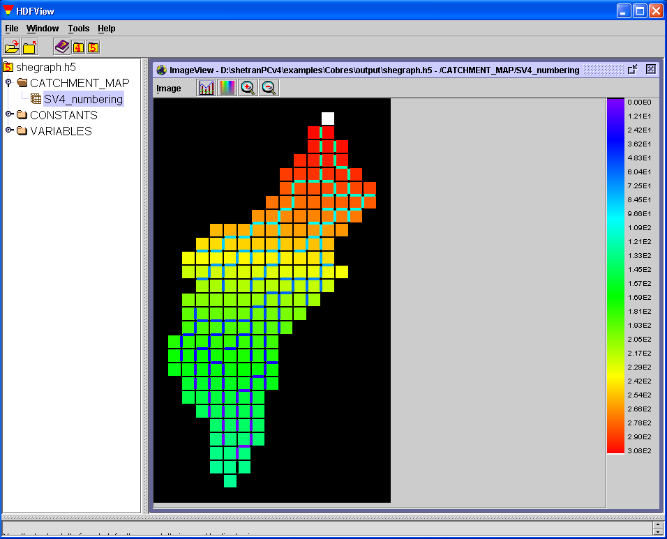
Figure 3.1 Shegrpah.h5 file showing the SV4_numbering in Catchment_Map

3.3 Constants

Constants are recorded for the data in Table 3.1. Each grid square can have associated with it a bank element on each side and a channel link on each side. So element type 1 is the grid square, types 2, 3, 4 and 5 are the banks on the north, east, south and west sides and types 6, 7, 8 and 9 are the river links on the north, east, south and west sides. Note, the difference between this and the faces in SHETRAN input files that are ordered east, north, west and south.

Data Item | Meaning
centroid | Grid coordinate. i.e distance (m) of the centre of the grid square from the top-left of the catchment
grid_dxy | Grid size (m) in the x and y direction
number | SHETRAN element number
r_span | Length of grid square (m) from the grid centroid to the edge of the grid square. Takes into account link and bank elements
soil_type | Soil type in each cell
surf_elv | Ground surface elevation
vert_thk | Vertical height of each cell
Table 3.1 Constants recorded in shegraph.h5 file

The Constant number has been selected in Figure 3.2 (by double-clicking), and the first two dimensions of this set can be seen in the table in the inset window. Each dataset has general properties. Right-clicking on the number dataset and selecting show properties brings up the Properties window (Figure 3.3). The number dataset is three-dimensional with an extent 29x17x9. The dataset has been compressed to level 9 (this is the maximum compression possible, and is the default level for SHEGRAPH HDF5 files). Chunking is to do with the way the data are stored, for efficiency of storage and retrieval. The three dimensions are defined by the dataset's attributes (to see these, click the attributes tab on the Properties window).
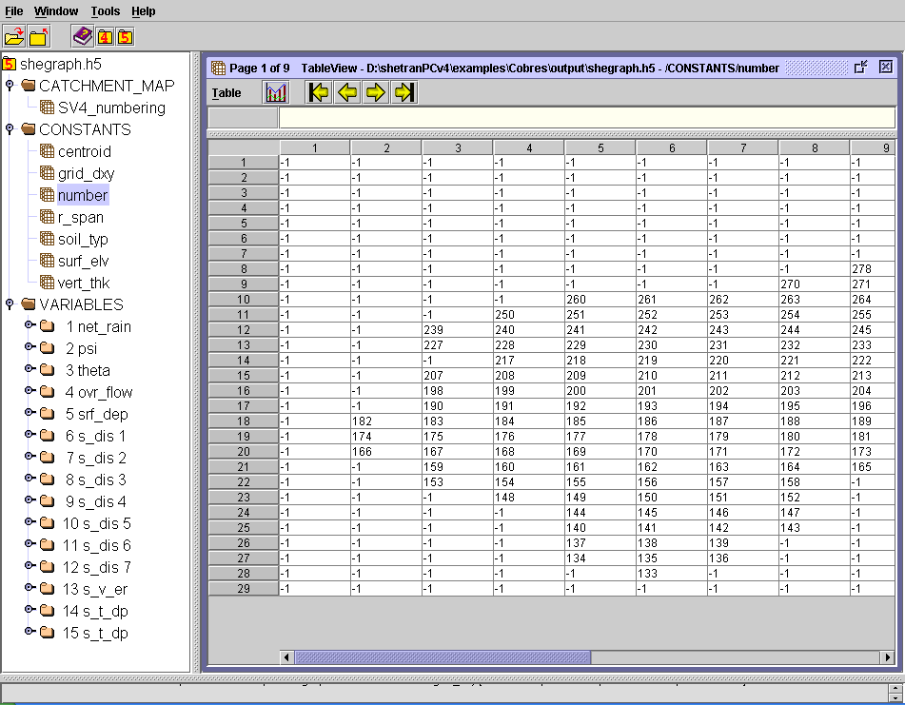
Figure 3.2 Shegrpah.h5 file showing SHETRAN element numbers

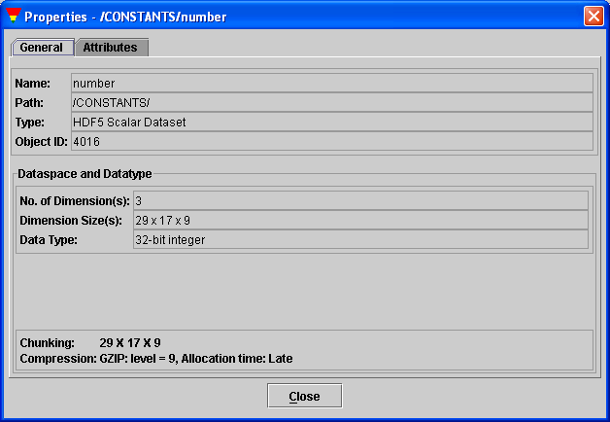
Figure 3.3 General properties for dataset number

Figure 3.4 shows the attributes for dataset number. The Value entry (column 2) for element types has been clicked so that its full contents are shown in the large box (squares are SV4 elements which are not banks and not river links). The first two dimensions in the dataset are for the location in the catchment's grid and the third is for the element type. To give an example, the value at location 1,3,5 in the dataset will be for the west bank (because element type 5 is W-bank) for the gridsquare at row 1 and column 3 in the catchment's grid. Had, for example, the dataset been for a grid section, with, say, row and column limits of 4 29 and 5 17, then the value at location 1,3,5 would have been for the west bank for row 4 and column 7 in the catchment's grid. Datasets for grids can have up to 6 dimensions and these can be seen in Table 3.2. For lists, the maximum number of dimensions is 5: Element-list, Element type, Layer, Extra, and Time.

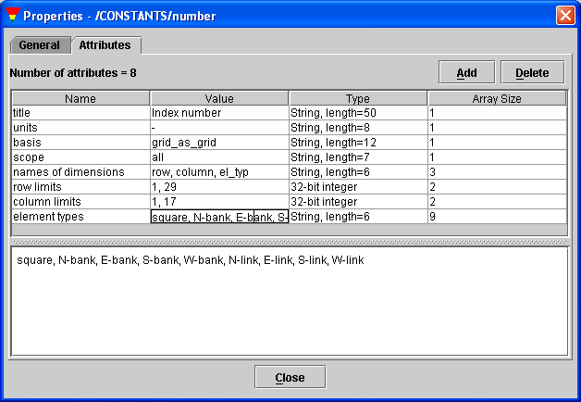
Figure 3.4 Attributes for dataset number

- Row | By convention, HDF5 rows are numbered top to bottom (i.e. North to South), starting at 1.
- Column | Columns are numbered left to right (i.e. West to East), starting at 1.
- Element type | This is relevant only if the scope is banks, rivers or all, in which cases it will, respectively, have extent 4, 4, or 9 (the 9 types are listed in Figure 3.4).
- Layer | Subsurface layer. The layers correspond to the layers of subsurface finite-difference cells in SV4. Layer 1 corresponds to the topmost finite-difference cells, layer 2 the second topmost finite-difference cells, and so on. Limits 3 24, for example, therefore specify the inclusive range from the third topmost cells to the 24th topmost cells. Limits specified backwards, e.g. 24 3, will automatically be reversed when read. It can be useful to study the constants vert_thk (vertical thickness) and soil_typ (soil type) when creating a visualisation_plan.txt file. Whenever a simulation is run (even a preliminary simulation where the visualisation_plan.txt file contains only the lines 'visualisation plan' and 'stop') these constants are automatically recorded for the entire extent of the finite-difference mesh, including any dummy layers of cells that SV4 add to the base of the mesh for computational purposes.
- Extra | Extra dimensions. The available options can be seen in Table 2.5.
- Time | Time has its own dataset and attributes. The time and value datasets are related in that the 29th, say, element in the time dimension of a value dataset applies at the time given in the 29th element of the corresponding time dataset.
Table 3.2 Data Types (dimensions) that can be recorded for grid datasets

3.4 Variables

There can be several datasets for the same variable, so the VARIABLES datasets are labelled with both the variable name (e.g. psi) and the item number specified by the user in the visualisation_plan.txt file. Dataset 2 psi (Figure 3.5) is for:
- Three by three SV4 grid (dimensions 0 and 1)
- layers 55 to 25 (dimension 2)
- 33 times (dimension 3)

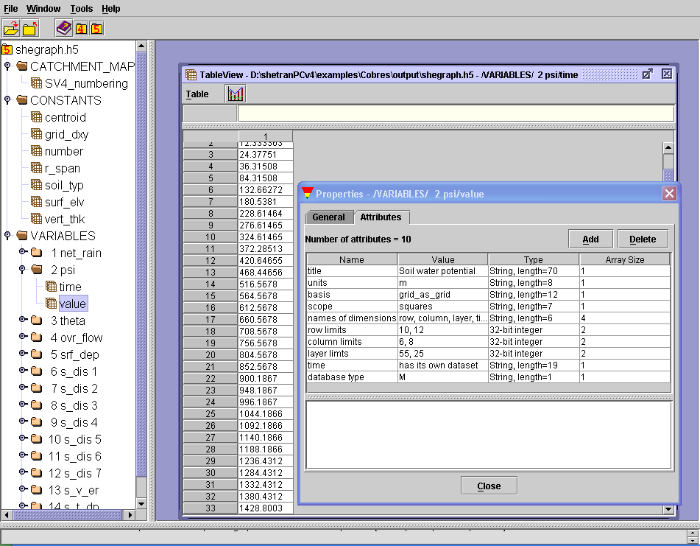
Figure 3.5 Dataset for time and attributes for value, both for item 2 psi

For some contaminant and sediment variables, data are recorded for only one contaminant or one sediment fraction, so the contaminant or sediment fraction number is included at the end of the label for the corresponding VARIABLES dataset. For example in Figure 3.5, item 8 is for sediment fraction 3 for the sediment variable s_dis.
Double-clicking on a dataset's name brings up a spreadsheet showing the first two dimensions of the dataset. What is more useful is to right click on the name and select open as from the drop-down menu. This brings up a Dataset Selection window (Figure 3.6). The main choice to be made is then whether to view the data on a spreadsheet or as a 2-dimensional plot (click either the spreadsheet or image button). Both the spreadsheet and plot are 2-dimensional, so can only show a 2-dimensional slice through the dataset (e.g. for a 6-dimensional set it could, for example, show the slice for dimensions 3 and 5, with the values for all the other dimensions remaining constant). The selected dimensions run along the height (vertical) and width (horizontal) edges of the spreadsheet or image.

In Figure 3.6, dimension 0 is for the vertical part of the three by three grid and this is shown as the height in the spreadsheet, dimension 3 is the time and this is shown as the width. The depth can also be specified. This works like a stack of paper. For example, in Figure 3.6 the depth has been set at dimension 2 (this is for the layer number) and there are data for 31 layers, so there are 31 sheets of paper in the stack. Each sheet of paper shows a spreadsheet or image, but each sheet is for a different layer. These pages can be leafed through using the arrows on the spreadsheet's or image's toolbar. In Figure 3.6 there is data for dimension 1, which is the horizontal part of the three by three grid. The constant values for this dimension can be set by clicking more in the Dataset Selection window.

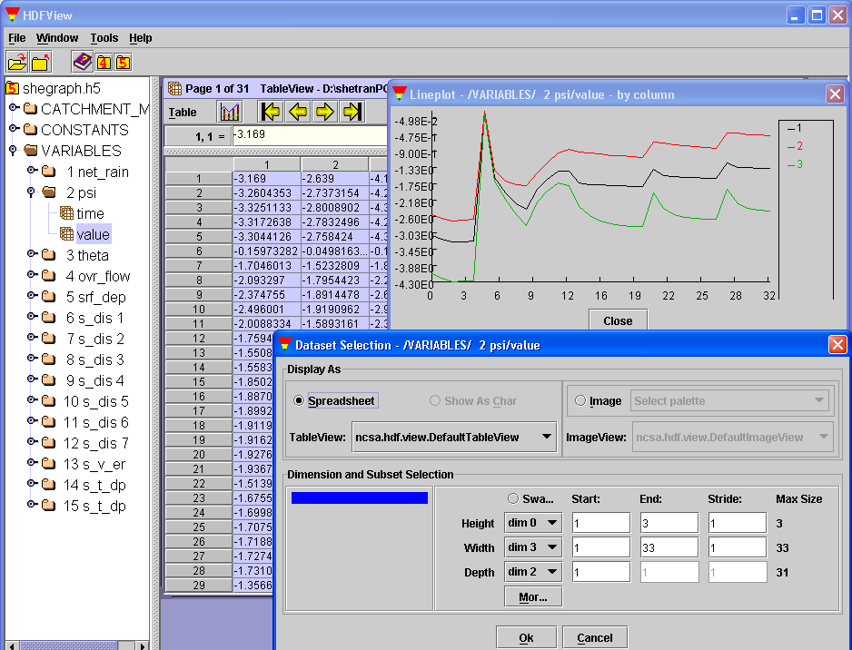
Figure 3.6 A 1-D plot for dataset 2 psi in a Lineplot window
For Figure 3.6, the spreadsheet option was selected and the spreadsheet which appeared is shown in the TableView window. Alongside the arrows on the toolbar in this window there is a graph icon. The 1-dimensional plot in the Lineplot window was created by selecting columns 1-3 in TableView and clicking this icon. Several rows or columns can be selected for a single lineplot. Also on the toolbar there is the word Table, clicking on this brings up a menu for various tasks such as saving selected table values to an ASCII file.

Figure 3.7 shows a 2-dimensional plot in an ImageView window (make sure that image is selected in the Data Selection window if you want an image and not a spreadsheet). Several options, including options for contouring, colour palettes and animation, can be accessed by clicking on the word image on the toolbar in the ImageView window. The image size in HDView depends on the size of the dataset (a big set gives a big image). Magnification in HDFView has a limited range (x0.125 to x8), which is a bit annoying when looking a small set, as it gives a small image even when x8 is used. Note, that this has nothing to do with the HDF5 files. Catchment_map has a simple form of magnification, so that a big image is seen in HDFView. Further dataset could be added in a similar manner.

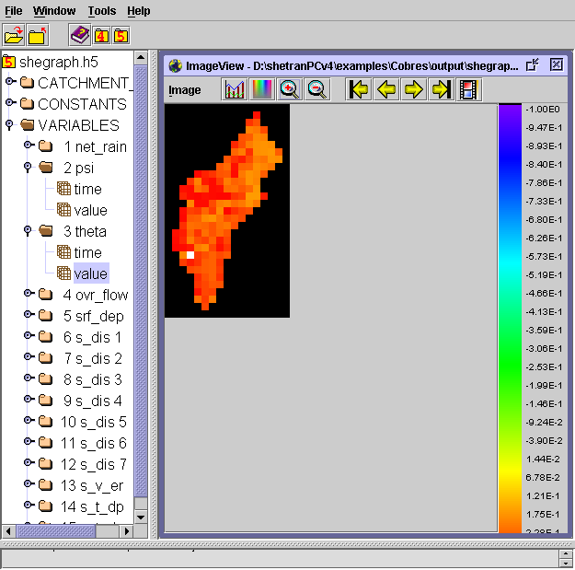
Figure 3.7 A 2-D plot for dataset theta in an ImageView window

Appendix A: Data File Formats for the Sediment and Contaminant Transport Components

This appendix defines certain generic formats used in the specification of input data files for the sediment and contaminant transport components of SHETRAN. The definitions should be interpreted within the context of FORTRAN 77 (ANSI X3.9-1978).

Each format corresponds to a sequence of formatted records within a data file. The first record of each format is always a title (or header). On input the contents of this record are transferred to a character variable of length 80, and are expected to contain some identifying code. Subsequent records within a format conform to the defintions below.

In the following the “format name” is the name by which the given format may be referred to; and the “format identifier” and “input/output list” are as defined in the FORTRAN 77 Standard. The definition of “input/output list items” is extended here to include those embedded within an implied-DO list. Wherever practical, list-directed input/output is specified (in which case the format identifer is simply an asterisk).

Some of the following data input formats are rather complex; these are best interpreted with the help of example data sets.

Integer List
Format name : I
Format identifier: *
Input/output list: List of input/output list items of type integer.

Floating-point List
Format name : F
Format identifier: *
Input/output list: List of input/output list items of type real or double precision.

Logical List
Format name : L
Format identifier: *
Input/output list: List of input/output list items of type logical.

Character List
Format name : Cn (eg C80) where n is the length of the input/output list item(s) into/from which the data are transferred.
Format identifier: ‘(A)’
Input/output list: List of input/output list items of type character.

Integer Grid-array
Format name : IG This format has an associated FLAG whose value (>1) is an upper bound on the range of values expected. If FLAG is less than 10 the integers are arranged as a grid of single digits.
Format identifier: ‘(I7,1X,nnnnI1)’ if FLAG<10, where nnnn is the east-west extent of the grid; or

* if FLAG>=10

Input/output list: IY,(IG(IX,IY),IX=1,nnnn) repeated NY times, where NY is the north-south extent of the grid, IG is the integer array defined on the grid, and IY is the row number. Rows are numbered from south to north, but must appear in north-south order, ie row NY first, through to row 1 last. The data for each row must begin on a new record.

Floating-point Grid-array
Format name : FG
Format identifier: *

Input/output list: IY,(IG(IX,IY),IX=1,nnnn) Analogous to the input/output list for format IG above. FG is an array of type real or double precision.

Floating-point Element-array
Format name : FA This is a composite format made up of a logically determined sequence of simple formats. It provides a choice of methods for the specification of a field of values FA(1:NEL,1:N2) covering the entire set of SHETRAN elements, where FA is an array of type real or double precision, NEL is the total number of elements and N2 is the size of the second dimension of FA (a one-dimensional array has N2=1). Values may be given directly, N2 per element; or there may be user-defined categories, with N2 values per category; or there may be other special options. The identifying code (eg :XY41) specified for the composite format applies directly to the “initial component” (below); subsequent components have the code augmented by their identifying letter (eg :XY41a).

Initial component: Determines the specification method.
Format I
Input/output list NCAT, interpreted as follows:
>0 number of user-defined categories;
=0 no categories – use direct values;
<0 special option (eg values derived from data defined elsewhere).

Note: The following two components (where present) are repeated as a pair N2 times, with subscipt n increasing from 1 to N2.

Component a: Link element values (present only if NCAT=0 and the number of link elements is non-zero).
Format F
Input/output list (FA(iel,n),iel=1,NLF), where NLF is the number of channel-link elements.

Component b: Grid element values (present only if NCAT=0).
Format FG
Input/output list IY,(FA(IX,IY),IX=1,nnnn), See format FG above.
Grid-element values for the array FA (with second subscript fixed at n) are defined in terms of FG values via SHETRAN’s grid-to-element conversion array.

Component c: Values for each category (present only if NCAT=0).
Format F
Input/output list ((FC(n,cat),n=1,N2),cat=1,NCAT) where FC is used temporarily to hold the values.

Component d: Category code for link elements (present only if NCAT>1 and NLF >0).
Format I
Input/output list (IA(iel),iel=1,NLF) such that IA and FC together define link-element values for FA thus: FA(iel,n) = FC (n,IA(iel)).

Component e: Category code for grid elements (present only if NCAT>1)
Format IG with FLAG=NCAT
Input/output list IY,(IG(IX,IY),IX=1,nnnn), See format IG above. Analygous to component d above, except that associations are made via the grid-to-element index array.

NB: Bank element values are defined by association with their neighbouring grid elements, provided such a neighbour exists; otherwise an association is made with the opposite bank.

Floating-point Column Element-array
Format name : FC This is identical to FA above, except that no values are required for link elements: components a and d are therefore omitted.

Appendix B: Mobile Sediment Concentration in SHETRAN

The sediment component represents the concentration of sediment carried by the flow with a non-dimensional quantity, FDEL. FDEL is the ratio of the depth that sediment would cover if it were allowed to settle, to the depth of the water column. In this hypothetical settling of sediment carried by the flow, it is assumed that the sediment settles such that its porosity is that of the bed sediment porosity in channels, or the loose sediment porosity of the hillslope. The mobile sediment concentration in the surface water of an element can thus be expressed as:

c_{i} = FDEL_{i} x ρ

where c is the concentration of sediment in size group I (mass of sediment per unit water volume), FDEL is the non-dimensional concentration of sediment in size group I, and ρ is the bulk density of bed sediment in the case of channel link, or the bulk density of loose sediment in the case of a hillslope element.

